Final Path Consulting



# Table of Contents

**Table of Contents** **1**

**Identification of Team Members** **5**

**Team Name** **6**

**Team Logo** **7**

**Team Communications Management Plan** **8**

**Client Memorandum of Agreement** **11**

**Client History/Background** **12**

**Client Organization Timeline** **13**

**Client Organization Chart** **14**

**Project Selection Analysis** **15**

**Initial Problem Statement and Problems and Requirements List** **17**

**Scope Diagram** **20**

**Data Gathering Goals** **21**

**Data Gathering Methods** **22**

**Data Gathering Questions** **23**

**Team Roles/Responsibilities Matrix** **24**

**Data Gathering Results** **26**

**Current System Description** **29**

**Current System Problem Description** **30**

**Client Organization Objective List** **31**

**Main Objectives** **31**

**Financial Objectives** **31**

**Client Services Objectives** **31**

**Client Application (System) Objective List** **32**

**Individual Users Objective List** **33**

**Brewmaster** **33**

**Taproom Manager** **33**

**Sales Manager** **33**

**Bartender & Brewers** **33**

**Strobe Analysis** **34**

**Samples of Records** **40**

**Initial Project Work Breakdown Structure** **44**

**Gantt Chart** **45**

**PERT Diagram** **46**

**Users/Stakeholders Analysis** **47**

**Initial Feasibility Analysis** **48**

**Technical** **48**

**Economic** **48**

**Operational** **49**

**Option 1** **50**

**Option 2** **51**

**Continued Updated Problems & Requirements List** **52**

**Critical Requirements Analysis Objective Tree** **54**

**Current Business Rule List** **55**

**Current Business Activity List** **56**

**Daily Taproom Activities** **56**

**Current Event Response Table** **57**

**Current System Data Flow Diagram** **59**

**Current Data Dictionary** **60**

**Current Entity Relationship Diagram** **64**

**Continued Updated Problems & Requirements List** **65**

**Client SWOT Analysis** **67**

**Systems Proposal** **68**

**Listing of Authors per Deliverable** **70**

**Sponsor’s Decision** **72**

**Business Background** **72**

**Problem Statement** **72**

**Proposed Solution** **72**

**High-Level Requirements** **73**

**Summary of Milestones & Deliverables** **73**

**Initial Stakeholder Register & Agreement to Proceed** **74**

**Continued Updated Problem’s & Requirements List** **75**

**Required System Entity Relationship Diagram** **78**

**Required System Business Rule List** **79**

**Required System Business Activity List** **80**

**Daily Taproom Activities** **80**

**Weekly Taproom Activities** **80**

**Quarterly Taproom Activities** **81**

**Yearly Taproom Activities** **81**

**Required System CRUD Matrix** **82**

**Use Case Scenarios** **83**

**Required Event Response Table** **105**

**Required System Data flow diagram** **107**

**Required system data dictionary** **111**

**Required System Feasibility Analysis** **113**

**Application Architecture Diagram** **115**

**Data Acquisition and Data Conversion Strategy** **116**

**Initial Draft of Testing Plan for Application and Database Creation** **117**

**Application Prototype** **118**

**Reports** **121**

**Updated Listing of Authors per Deliverable** **126**

**Complete List of References** **12**9

**Executive Summary of Project** **1**30

**Updated Client Background and Information** **1**31

**Final Problems and Requirements List** **13**2

Lessons learned

# **Identification of Team Members**

* Asarpota, Pratik ----------- prasarpota@uh.edu
* Izuegbu, John-Joshua -- joizuegbu@uh.edu
* Khan, Faryal --------------- ffkhan2@uh.edu
* Kukoyi, Adekunle --------- aokukoyi@uh.edu
* Lazard, Chantera --------- cclazard@uh.edu
* Tran, Sean ------------------ sttran5@uh.edu

# **Team Name**

* Silver Lining Consultancy
* General Analysis Consulting
* Blackbourne Consulting LLP
* Advice Associates
* The Consultants
* The Advisors
* Partners Prestige Consulting Group
* T.A.K.L.I.K Consulting
* **Final Path Consulting**

# **Team Logo**



# Team Communications Management Plan

Prepared by: Faryal Khan Date: February 14, 2020 Version: 1

Introduction

Since communication is an extremely important key when it comes to succeeding in a project, our team is making sure that we communicate accordingly and our constantly keeping in check what updates or issues we need to work on as a team and as individuals. We have also met with the professor regarding our assignment and have also emailed her regarding any issues that we face. In terms of our client, our group has conducted several interviews at client’s location and have visited the location several times to analyze their system and observe their environment.

Collection and Handling project information

To make sure that all groups members can access all documents, we are using google drive. Our project manager created the google drive folder and its where the entire team is responsible for posting their deliverables. Since google drive makes it easy for everyone to view and edit the deliverables, the entire team can participate in collaborating or adding any sort of modifications to all deliverables. Sample of records that are provided by clients are stored in a paper filing system.

Distribution structure (what information goes to whom, when, and how)

Fortunately, through the use of google drive, the entire team can keep up with all deliverables since everyone is required to submit their deliverable on the drive by specific date assigned to each individual. Besides just using google drive to share our documents, our team is also constantly communicating at least once or twice a day through our group’s GroupMe chat to inform other team members on updates or questions regarding their deliverables. Weekly meetings are a great way for the entire team to collaborate and share any concerns they are having regarding their deliverables.

Format, content, and level of detail of key project information

All team members are responsible for writing and updating their deliverables in a professional manner with proper header, footer and name of author. It’s also important to add the team logo on the header section of each deliverable. Our team is making sure that all communications are done in a formal and professional manner.

During the Mid project, our team will submit all of their deliverables up until the systems proposal in a binder and will provide a 10-12 minutes presentation regarding our client, our systems development approach and key deliverables as well.

Production schedule and resources for producing key project information

1. Start up meeting: This meeting is done to provide scope for the project, meet your team members and understand responsibilities and skills of each member.
2. Weekly meetings: In this meeting, every Tuesday after class, our group meets, and records deliverables done and if there is any sort of concern, that is addressed as well.
3. Deliverable updates: Every team member is responsible for posting their respective deliverable on the date it is due with proper format on google drive.

Technologies, access methods, and frequency of communications

Google drive is an excellent form of cloud storage that our team is using to constantly post any sort of deliverable and updates on, which also serves as a great platform for the entire team to collaborate together and review deliverables of their peers as well in order to provide constructive criticism. Most of communication is done through GroupMe chat, emails or face-to-face conversations. Since the team meets weekly, it’s extremely important for members to constantly update and communicate with their peers in regard to their deliverables via group messaging or emails. Communication is very frequent and team members communicate with each other almost daily. Team will also rely on Microsoft projects and visible analysts in order to work on graphical charts and diagrams required for this project.

Method for updating the communications management plan

If a group member has any concern about updating or modifying the communications management plan, they can talk to the project manager regarding their concern and the project manager can update the communications management plan.

Escalation Procedures

If any team member has any sort of issue or concern, they are encouraged to resolve it as soon as possible since any sort of conflict can negatively impact a project either short term or long term. Team members are expected to help out their fellow peers if they are confused about certain deliverables and need guidance.

Stakeholder communications analysis

|  |  |  |  |  |
| --- | --- | --- | --- | --- |
| Stakeholders | Document/  Communications Name | Document/ Delivery Method Format | Contact Person/ Producer | Due Date/Frequency |
| Project team | Weekly updates | Hard copy, weekly meeting, Google drive is used for updating deliverable | John-Joshua Izuegbu, Pratik Asarpota | Tuesdays 4pm |
| Client’s Organization | Monthly status report | Hard copy and monthly meetings | Sean Tran | Depends on client’s availability |
| Project steering committee | Weekly updates | Weekly meetings | Faryal Khan, Adekunle Kukoyi and Chantera Lazard | Tuesdays 4pm |

Glossary of terms

* Visible analyst= Software that is used for data storage and organizational documents.
* Microsoft project = Software used for project management in order to stay organized and manage activities of their respective projects.

# Client Memorandum of Agreement

THIS AGREEMENT (herein referred to as “Agreement”) is made and entered into the ___14___ day in the month of _____February______ of the year 20_20__ by and between your organization, Klaus Brewing Company, and our project team, Final Path Consulting. This letter is an agreement that your organization will assist and adhere to the *project criteria and guidelines* below. The timeframe with our project team will be for the next two (2) semesters (Spring 2020-Spring 2021).

Project Criteria and Guidelines

*The project will consist of the following:*

* Building, analyzing, and testing a database system customized for your business.
* The system analysis will consist of fake or “dummy” data supplied by your company.
* All fake/fabricated data will be confidential and only shared within the project team.
* Any implementation and population of data into the database will only be at the discretion of your firm.

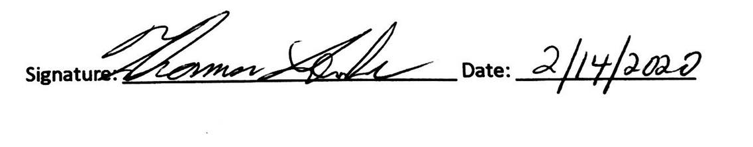

# Client History/Background

Klaus Brewing Company was founded by a local group of family and friends led by passionate brewer Thomas Lemke. Focused on bringing the under-served German-style beers to a wide range of consumers, from beer aficionados to new converts alike. They chose the name Klaus because they wanted a strong traditional German name. The name's meaning is "The People’s Victory". The company feels being able to offer people the ability to experience great locally crafted beer in a welcoming environment is truly a victory for everyone.

# Client Organization Timeline

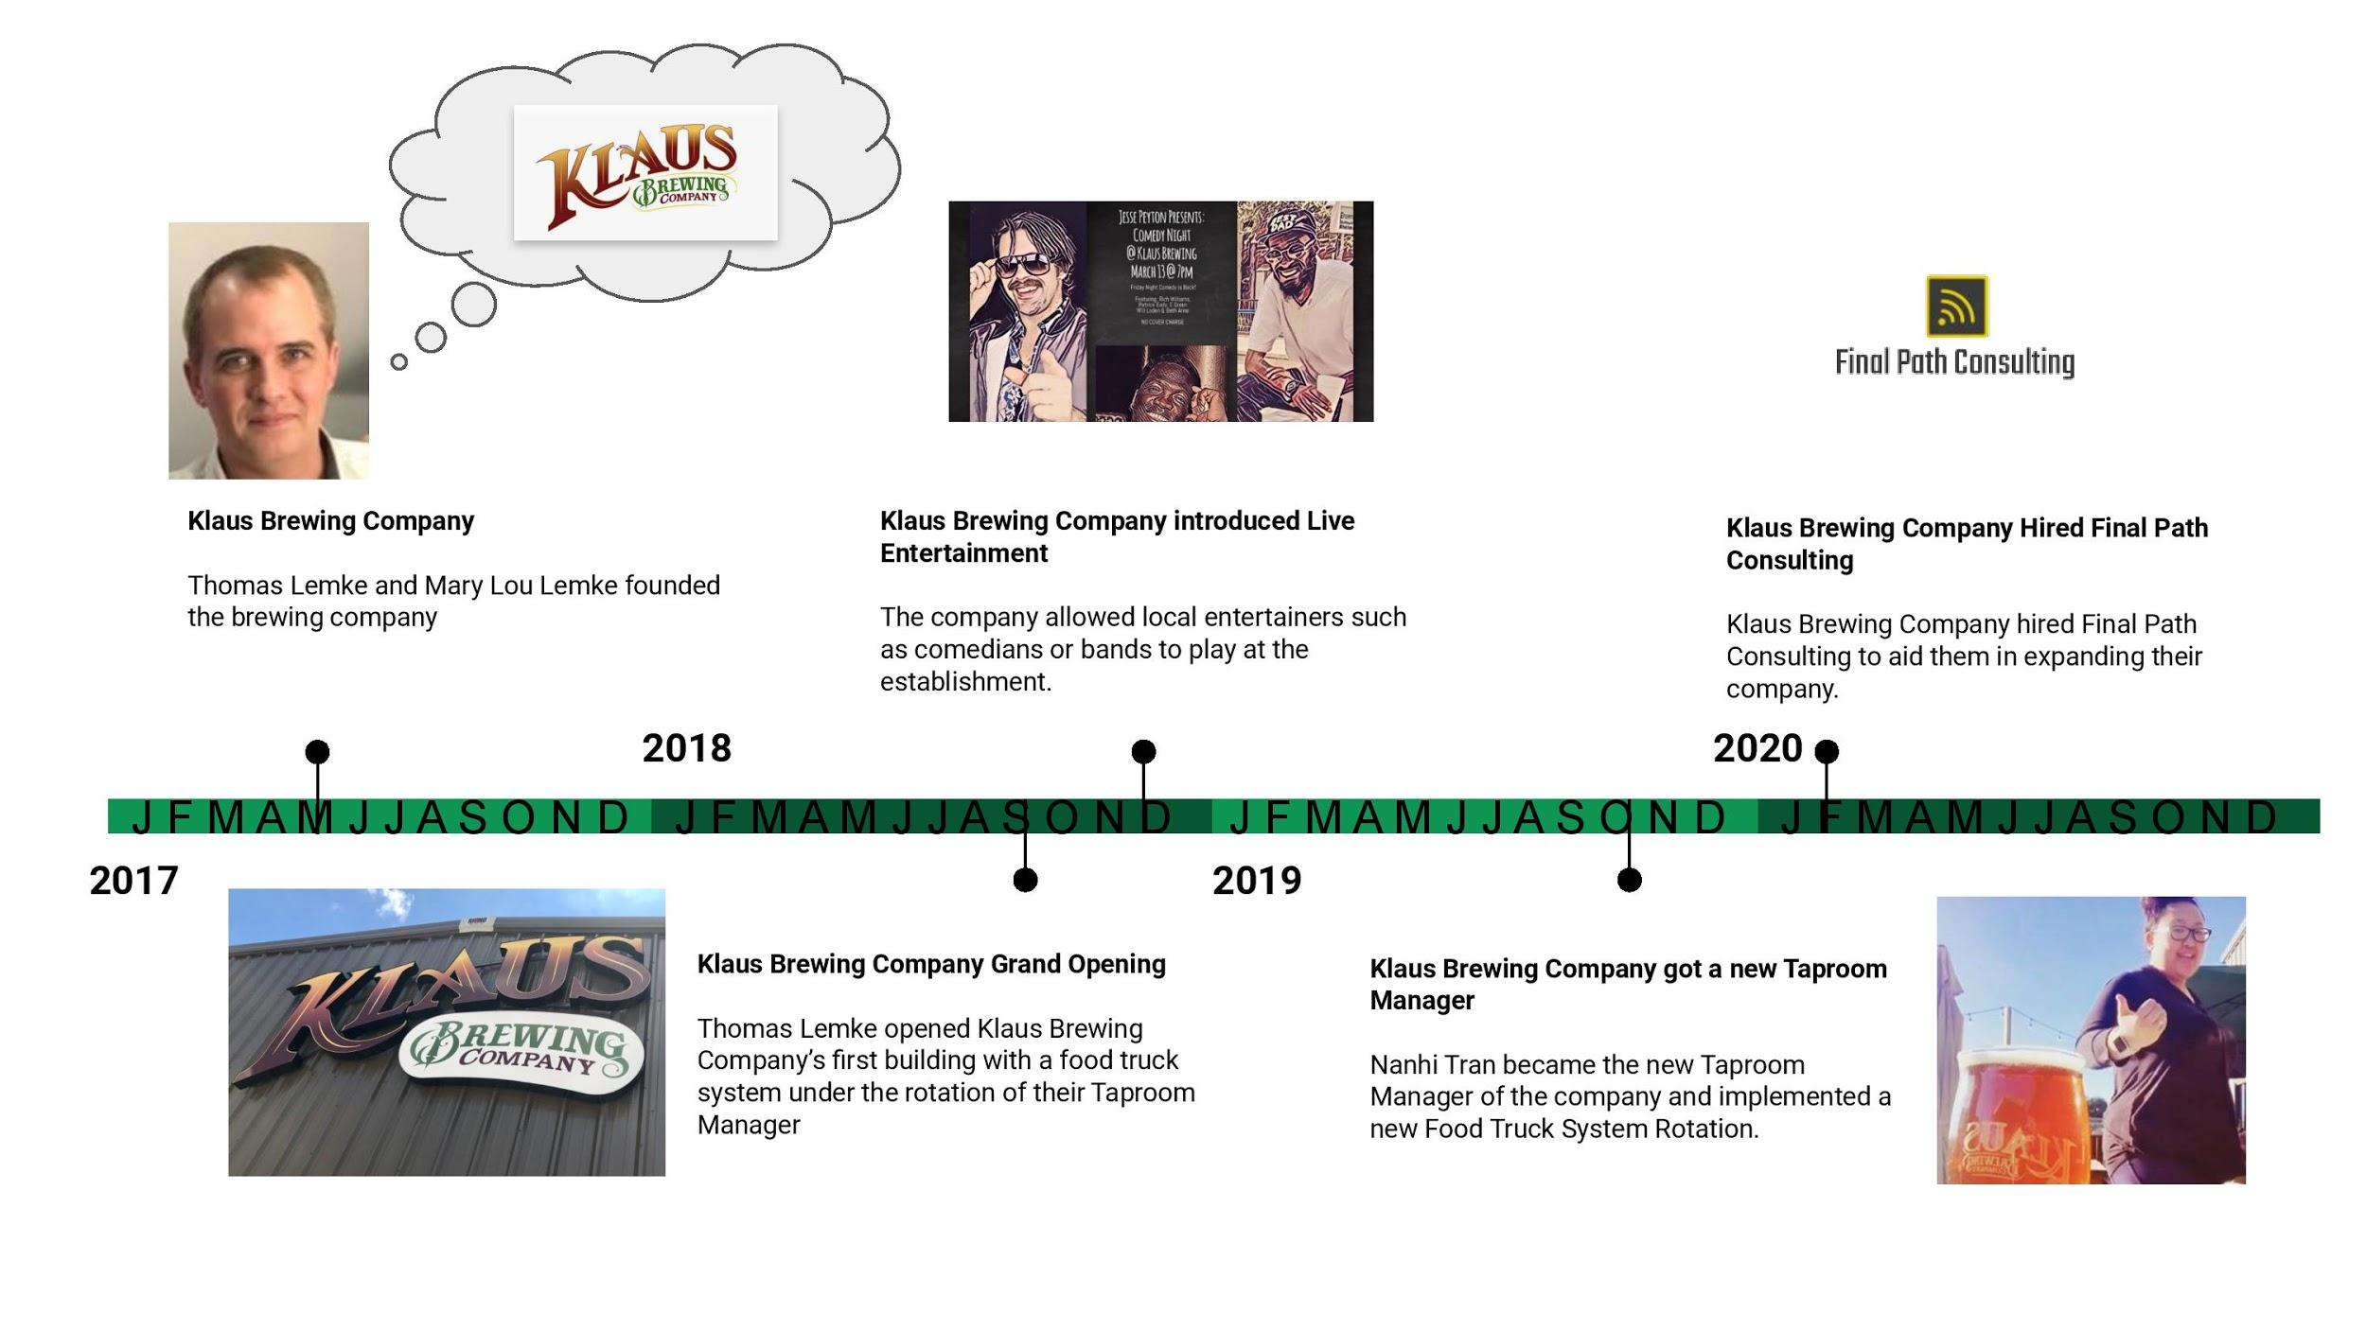

# Client Organization Chart

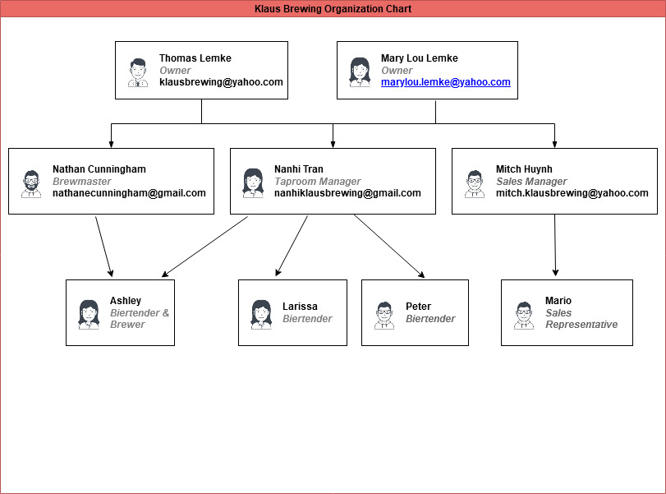

# Project Selection Analysis

To select our client, our project manager, John-Joshua, asked us to contact 3 businesses that would be willing to do the project. We all had separate strategies on how we searched for clients. Some of us did research and looked into small local businesses and contacted them. Others took a day out to visit small businesses near them. A few of us knew people with local businesses and reached out to them. Our team reached out to various companies including book stores, grocery stores, and bakeries. Yet, all the companies were showing disinterest. After a week and a half, none of our team members were able to meet our goal. So, we had a discussion concerning why we were not successful. The main problem was we weren’t sure what we were offering. We assumed we were trying to help them with IT issues. John-Joshua explained our purpose to us and some questions we could ask. He stated that we should approach companies not stating that we are trying to improve their IT department. Instead, we will analyze their current problems and figure out how to increase their efficiency and cash flow. With this in mind, we set out again looking for clients still utilizing our same strategies in finding new clients, but employing different narratives in what we could offer them. In the end, we had 3 potential clients.

Our first potential client was a salon named MC hair salon discovered by Fayal. She was able to speak to the owner and the owner was interested in Final Path Consulting helping her. On Fayal’s initial visits, she discovered the owner was steadily losing customers. She wanted to improve customer communication, improve marketing and advertising strategies to attract new customers, and improve her current scheduling and inventory database. The reason we chose not to work with her was Fayal was trying to follow up with the owner and she was having trouble getting in touch with her. Eventually, the owner responded and stated she was uninterested because she was not able to commit since she was too busy.

Our second potential client was a manufacturing company named Umbilicals International discovered by Chantera. She focused on the accounting department because it consisted of two individuals and her mother worked there so she was familiar with their issues. She talked to the Accounting Manager and deduced their 2 major issues. They wanted to increase communication between other departments and between each other. The manufacturing department gets orders from customers. When they send the orders out, the accounting department is supposed to keep up with the sales so they can collect the money from their customers. The issue is there is no system in place for the accountant department to know when the manufacturing department sends out the products. This caused the business to lose money because some customers were receiving products for free. Another problem was the two the accountant department wanted a database that would merge all their work to increase efficiency and communication between both parties. The reason we decided not to go with this client is that Umbilicals international recently switched CEOs and they were unsure if the new CEO would give them clearance to share information with our Consulting Firm.

Our last potential client was a brewery named Klaus Brewing Company discovered by Sean. Sean was able to secure the brewery as our client. Sean scouted this client because his sister works at the Brewery and is able to discuss problems with him even after hours which would be beneficial to both parties. Klaus Brewing Company’s executives would only have to take minimal time out of their busy work hours to meet with us if deemed appropriate and we would be able to get information quickly when needed. We chose to create for them a loyalty program and order processing system because it would allow us to aid them in their other problems including establishing a computerized order tracking database since the rewards system could potentially allow us to personalize the customer’s orders by keeping track of their favorite orders and giving them rewards on their birthday. The rewards would need an updated website that would advertise the new loyalty rewards and provide more information. It would also potentially give them a better social media presence if an added feature was added that provided a relationship with the rewards system and social media such as giving customers more points for advertising the products by adding pictures while tagging the company official page.

This is a very new company that is looking to expand within the next 5 years to several other locations. If we are able to establish a successful loyalty system, we could provide more profit for Klaus Brewing Company to aid in their expansion since the free advertisement is a byproduct of the loyalty program. We also could create a program that would be adopted in the new locations which would provide more free advertisement and allow the customers to use their perks in all locations. Lastly, Klaus Brewing Company provides food through its partnerships with food truck vendors. The advertisement would not just help our client but the food truck vendors which leads to more profit for all parties. Our client would also develop a reputation that could lead to more partnerships in the future.

# Initial Problem Statement and Problems and Requirements List

Our client, Klaus Brewing Company, has a few needs that they want to be implemented into their business. Their current client management program needs to be further completed and fortified. An ideal approach for the client would be that the client management program should have the ability to allow customers to feel as though they are the priority and to reward loyalty overtime. Second, the company would like to take advantage of the client information to also send advertisements and deals to their loyal customers. Third, their order processing system is out of date. They are able to receive orders, but they do not have the ability to track orders. The client would like an order processing system that tracks customer’s orders and eventually assigns it to the customer via the customer management program.

Our client will need a complex system that tracks orders and assigns it to a customer via an established client database. The system would also have to analyze these orders in a way to assist the company in creating a loyalty program for recurring customers as well as allow the company to send exclusive deals to their loyal customers.

|  |  |  |  |  |  |  |  |  |  |
| --- | --- | --- | --- | --- | --- | --- | --- | --- | --- |
| Ref Number | Problem Description | Source | Date | Priority (M, K, D) | Rank | Requirements Description | Current Perfor-mance (Excellent, Fair, Poor) | Required Perfor-mance | Scope ("in" or "out") |
| 2 | Upload spreadsheet form of merchandise and beir | Nahni | 02/16/2020 | M | 5 | Solution allows for uploading of current spreadsheets | P | E | In |
| 5 | Loyalty Program table population | Nandhi | 11/6/2019 | M | 7 | Solution allows for table to be created depicting customer lastingness in brewery and what was purchased | F | E | In |
| 1 | Electronic access to resources | Nahni & Group | 02/10/20 | K | 1 | Create solution that allows company to access any forms, reports, customer info and inventory online | P | E | In |
| 4 | Forms to handle customer profiles | Group & Nandhi | 02/16/2020 | K | 3 | Solution allows customer to input data and create profile from information | F | E | In |
| 6 | Pull up Customer Loyalty Report | Nandhi | 11/6/2019 | K | 4 | Solution allows ET to pull up any and all completed reports and tables of customer info related to purchased items | F | E | In |
| 3 | Live update of merchandise inventory | Nandhi | 02/16/2020 | D | 8 | Solution allows client to see up-to-date readings of inventory and orders from vendors | P | F | In |

# Scope Diagram

## 

# Data Gathering Goals

* Our goal is to understand the overall scope and method of the way Klaus brewery functions.
* It’s also important to get information about the problems they are facing so it can be easier to analyze and come up with a system's proposal.
* We also need to find out what services they offer and what methods they are using to improve those services.
* We need to understand the organization's entities and their relationships among each other.
* It’s also important to understand what form of marketing they are utilizing. For example, are they promoting their brand through social media, ads or emails?
* We need to understand who is responsible for several departments and what techniques are they using to oversee
* Client’s main problem is their current order processing so it’s important to properly understand their current order processing system and what are potential causes for that ?

# Data Gathering Methods

We have decided to take a funnel approach for our interview. The questions will start as open ended questions and the interview will conclude with closed ended questions. Final Path Consulting decided to take advantage of one of our team member’s relationships with Klaus Brewing Company. Sean has a family member who is one of the managers of our client’s establishment and he has been able to text, call, and meet in person with her. This is best for our client’s schedule at the moment and since Sean can meet up with her after hours, it is advantageous for both parties. Our team has written up a list of data gathering questions he will be asking the client’s representative during a scheduled interview at the Klaus Brewing Company’s establishment. He will then document and record the interview as well as make observations. He then sends the recording to us via our group chat and/or transcribes the recording to a google document shared amongst our team members so we can generate a rough list of our client’s problems and requirements. Eventually, we will all be able to meet Klaus Brewery’s representative and set up better communication methods so everyone can easily have access to our client. We will analyze their current system including their documents and records. This will allow us to refine our list of Klaus Brewery’s problems and requirements.

# Data Gathering Questions

* Open ended question
* Close ended question
* How would you describe Klaus Brewery?
* What services does Klaus brewing company offer?
* Can you briefly explain your current order processing system and what issues are you facing because of it?
* Do you have current methods for brand visibility? Any email or newsletter sign up available for customers?
* Physical environment can play a huge role in terms of marketing and your customers need to feel comfortable in the set environment. Describe the environment of Klaus brewing. How would you describe an employee's interaction with customers?
* How do you want to structure your loyalty rewards program?
* Providing customer service through social media can help a business improve their reputation. Are you providing customer service by responding back to your customers comments, post and complaints? If so, how do you respond back ?
* Is there a way to measure your social media marketing metrics? Are tools like google analytics used to measure your social media statistics?
* Which department is responsible for monitoring order processing?
* What are procedures for cycle count and in what specific way are they documented?
* What additional features do you want to add to your website? For example, are you interested in increasing your usual number of visitors or want to add some tool that clients can make their order online?
* Is it possible for you to provide a google analytics report for your website?
* Who is your target audience? (Asking this can be used to determine website’s appearance or layout for target audience).
* What specific features are you willing to offer your returning customers as rewards?
* What exactly is your brewery aiming to accomplish through social media?
* What current social media sites is your company using?
* Who is responsible for your social media marketing and how often do they post on these sites?
* Hashtag campaigns can be a great addition towards marketing. Do you have a current hashtag campaign? if not what would your hashtag be?

## 

## 

# Team Roles/Responsibilities Matrix

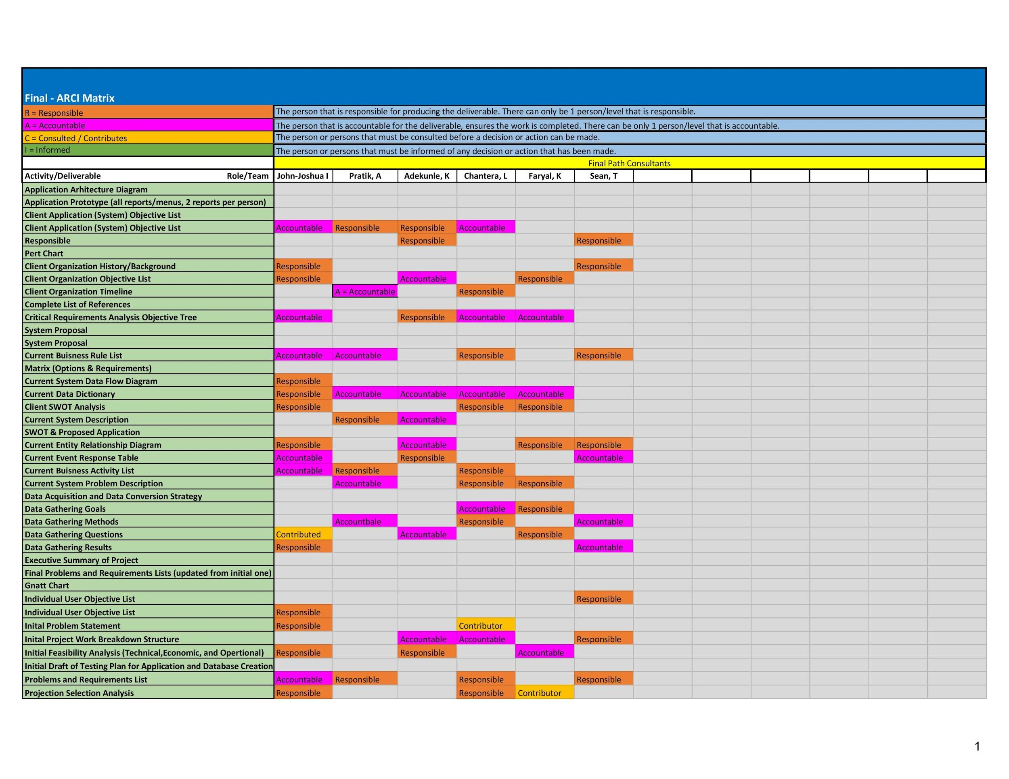

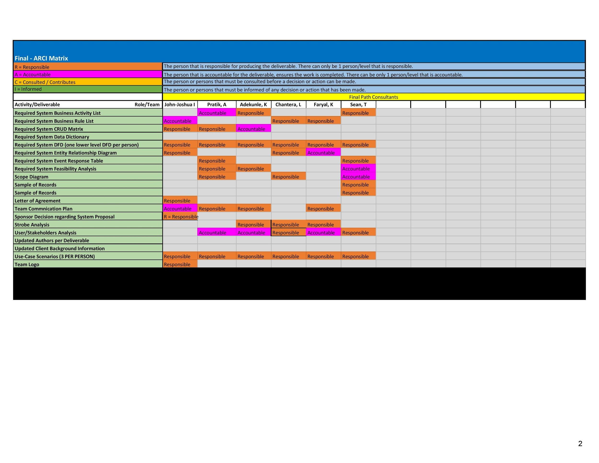

# Data Gathering Results

1. Can you describe your business in a few words?
   1. Klaus Brewing Company crafts German style bier and offers a taproom and biergarten for those that would like to enjoy an onsite experience.
2. What services does Klaus brewing company offer?
   1. Klaus Brewing currently sells their bier to other local bars and restaurants in the greater Houston area.
3. Can you briefly explain your current system and what issues are you facing because of it?
   1. Marketing – Currently no system in place, no email distribution at all for promotions and events.
   2. Shipping and Procurement – paper, by hand.
4. Which department is responsible for monitoring shipments and what techniques do they use?
   1. The taproom department is responsible for monitoring shipments.
   2. Maintaining records of shipments and major transactions is done manually via paper and pencil.
5. What are procedures for cycle count and in what specific way are they documented?
   1. Cycles are by season (four). Reports are made through Square. Reports only document how much money was made, nothing in depth or specific.
6. What systems in your business need improvement?
   1. Marketing – Mass emails for promotions, events, etc.
   2. Website – More interactive, more appealing, easier to use.
   3. Shipment – Use more electronic means to record data.
7. Would you want to create invoices and reports for the systems?
   1. No need for invoices. Square already produces satisfactory reports.
8. How would you all like to interact with the new system?
   1. Via computer. It must be easy to access and easy to use for the non-technologically inclined.
   2. Ideally add an email into a database and have the ability to mass email that list.
9. Do you currently have a database that we can host here and connect to it?
   1. Yes. Square database
10. What additional features do you want to add to your website? For example, are you interested in increasing your usual number of visitors or want to add some tool that clients can make their order online?
    1. The website should have a contact form and food truck, entertainment and event calendar.
11. What parts of your processes are slow or come to stall during business practices.
    1. Social media and marketing. Currently the responsibilities are all on one person and done by hand.
12. Is it possible for you to provide a google analytics report for your website?
    1. No
13. Do you have current methods for brand visibility? Any email or newsletter sign up available for customers?
    1. No methods for brand visibility, most it is by mouth
14. Who is your target audience? (Asking this can be used to determine website’s appearance or layout for target audience).
    1. Target audience is adults. Currently, most customers are generation X. Klaus wants more millennials (21-35) because they drink more.
15. How do you want to structure your loyalty rewards program?
    1. Dollar based. Every X amount you spend, you get Y amount back.
16. What specific features are you willing to offer your returning customers as rewards?
    1. Rewards can include things such as to-go bottles, merchandise and tokens (one token = one point).

1. Physical environment can play a huge role in terms of marketing and your customers need to feel comfortable in the set environment. Describe the environment of Klaus brewing. How would you describe an employee’s interaction with customers?
   1. Environment: Casual, comfortable, family & pet-friendly, social.
   2. Interaction with customers: highly interactive, friendly, fast-paced. Frequent returning customers
2. What is your brewery aiming to accomplish through social media?
   1. Exposure, which leads to more brand visibility, more customers through the door, more brand-customer interactions.
3. What current social media sites is your company using?
   1. Facebook, Instagram
4. Who is responsible for your social media marketing and how often do they post on these sites?
   1. Nanhi Tran is responsible for social media marketing. Her current goal is 5-6 posts a week.
5. Providing customer service through social media can help a business improve their reputation. Are you providing customer service by responding back to your customers comments, post and complaints?
   1. Yes. Basic customer service through social media. Liking posts, sharing posts, asking customers to come in whenever they have a complaint.
6. Is there a way to measure your social media marketing metrics? Are tools like google analytics used to measure your social media statistics?
   1. Not sure if there’s a way to measure social media marketing metrics. Facebook Pages for business but she doesn’t know how to read it.
7. Hashtag campaigns can be a great addition towards marketing. Do you have a current hashtag campaign? if not what would your hashtag be?
   1. No current active hashtag campaigns. #KlausInYourHouse
8. What are the overall company objectives in the next 3-5 years?
   1. EXPANSION. Bigger Facility, Bigger Brand. Similar to Saint Arnold
9. What are the current business rules
   1. TABC compliance. What can be given out? All decisions are approved by boss/CEO. Small company.

# Current System Description

The scope of our project pertains to the systems involved in the taproom. The taproom is over serving customers. Their current system within scope includes a POS system which is employed to sell customers merchandise and/or bier. The order is placed via the POS system. The customer has an option of keeping a tab open or paying now. If a customer chooses to keep a tab open, they will hand the biertender their credit card which is filed by last name. When they want to close the tab they will go back to the biertender, give their name, and finish paying. If they pay now, the customer just hands the biertender their method of payment. There are three methods of payment: cash, credit card, and tokens. Tokens are sold in pairs of two and three. A customer buys tokens and they are allowed to cash them in for any core beer which are Klaus Brewing Company’s main bier. Once they finish making their payment they will receive a receipt.

Klaus Brewing Company does not have a loyalty program in place nor a way to get in contact with clients. They do advertisements around the taproom by printing flyers and posting them in the bathroom and customizing their menu boards. They also might post advertisements via the website.

# Current System Problem Description

One of the major issues that Klaus Brewing Company is facing is their disorganized and outdated order processing system. Their order management is done through use of paper instead of electronically and is done manually. Since paper documents can be easily lost or can be compromised due to human error, it can put their business at risk of losing valuable supply and putting up accidental orders. Since error is very common when order procurement is done manually, it has caused loss of money due to error correction by making up for either lost paper documents which can be used as receipt.

Another problem that clients are facing is their lack of a loyalty rewards program. Currently, Klaus brewery does not have any sort of loyalty rewards program which can be used in order to reward returning customers by giving them some sort of discount or other benefit. With lack of a loyalty rewards program and in a Houston market where breweries can be a competitive business, clients are losing potential customers and can gain loyal members by offering them some sort of benefits or a point system encouraging them to return to Klaus Brewery. The order processing system also does not have a way to track orders so to analyze patterns and assign orders to customers.

Client’s next problem is with their current web site system. Client has an outdated web page which is not engaging and its not aesthetically pleasing. Their current website is also not connected to their database system. They would like their website to be more interactive and something that can attract more customers. Clients also want to improve their social media presence so they can utilize social media in order to gain more customers and for marketing of their brand.

# Client Organization Objective List

## Main Objectives

* To design and offer a graphical user interface application with an SQL database system for Klaus Brewing Co.
* To develop a customer loyalty program that is more pleasing to ownership and new customers.
* To allow more customer interaction with incentives discovered through the system.

## Financial Objectives

* To raise revenue through the new system and efficient practices.
* To enhance client presence by use of the business application.

## Client Services Objectives

* To reduce time spent on tasks by refining the data capturing, storing, and retrieving methods through the implementation of an SQL database system so business information can be handled easily, effectively, and safely.
* To improve the organization's current filing and storage system to handle: procurement, order_shipping, order_procurment, and other tasks of that nature.
* To improve customer turnout and engagement with the use of the system to notify of recurring customers and given client discounts.
* To improve the scalability of the current Klaus Brewing Co., from building size, systems capability, and customer base size.

# Client Application (System) Objective List

Our proposed system will be considered successful if it helps our client in meeting their business goals, streamline processes, and keep a better track of business data. The client application objectives are listed as follows:

* To create a computerized order processing system in a way that ensures a 100% increase in data storage efficiency so that employees can access information on products and customers faster. Can be measured by the number of taproom employees who can successfully use the system.
* To create a loyalty rewards program in a way that helps reward customers that return so that we get a 20% increase in customers that keep buying products from Klaus Brewing. Can be measured by the number of increased customers that register for the loyalty program.

|  |  |  |  |
| --- | --- | --- | --- |
| Objective | Current Level | Future Level | Time Frame |
| Order Processing System | 0 employee | All Taproom Employees (5) | 3 months |
| Loyalty program | 0 customers | 90-120 customers | 12 months |

# Individual Users Objective List

## Brewmaster

* + Data entry to be computerized and stored, and for data entry to be simplified. Uniformed data format for each department to use.

## Taproom Manager

* + Computer access to the system and fluidity of the app.
  + Ability to see up-to-date readings of inventory on hand.
  + Ability to place orders at notified time
  + Encourage more customers to return
  + Bring in more of the younger adult crowd

## Sales Manager

* + Ability to get notifications of recurring customers.
  + Ability to connect to a larger customer base (use forms)

## Bartender & Brewers

* + Ability to see up-to-date readings of inventory on hand.
  + Ability to place orders at notified time.

# Strobe Analysis

|  |
| --- |
|  |
|  |

|  |
| --- |
|  |
|  |

|  |
| --- |
|  |
|  |

|  |
| --- |
|  |
|  |

|  |
| --- |
|  |
|  |

|  |
| --- |
|  |
|  |

# Samples of Records

|  |
| --- |
|  |

|  |
| --- |
|  |

|  |
| --- |
|  |

|  |
| --- |
|  |

# Initial Project Work Breakdown Structure

# 

|  |
| --- |
|  |

# 

# Gantt Chart

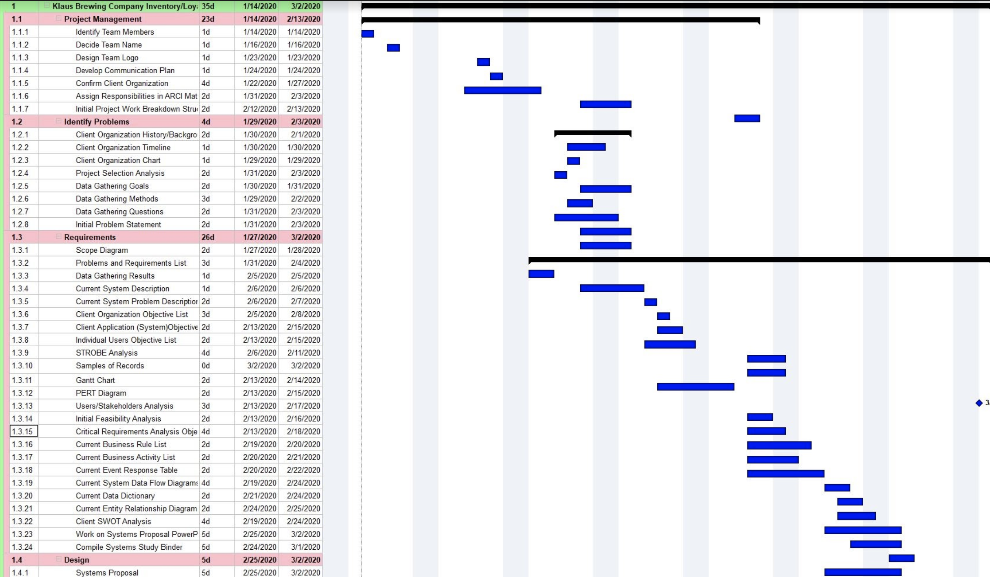

# PERT Diagram

## 

## 

## 

## 

# Users/Stakeholders Analysis

## 

## 

# Initial Feasibility Analysis

# Technical

The analysis was based on the company’s current technical situation and the future requirements for the new system. We have found that our client is going to need at least 2 dedicated PC’s or a tablet that will have the capability of connecting to a server. With that the client needs a -data server being cloud based or an in-house system. The creation of a new system with a data server will help with the issue of storing data in physical folders. Klaus Brewery's technical department consists of nobody that can assist with common technical issues other than employees in other departments. The new system will be very simple; therefore, minimal training is needed for Klaus’s staff members.

# Economic

The economic feasibility of implementing a system is very possible. By ruling on the class requirements, building and development of said application is on the house or will be waived by the “Cougar Discount” for the opportunity to create the application. So the development cost of the actual software is free. But the hardware cost of the PC’s and the server will come down to a cost. For the PC’s we can utilize” Dell OptiPlex 3050 Micro desktop computer” that runs for around $765.22 at Wal-Mart (<https://www.walmart.com/ip/Dell-OptiPlex-3050-Core-i5-7500-3-4-GHz-8-GB-500-GB/855902196?irgwc=1&sourceid=imp_U%3A8Tvx1JyxyORUzwUx0Mo3chUknV9V0nuQSz140&veh=aff&wmlspartner=imp_1943169&clickid=U%3A8Tvx1JyxyORUzwUx0Mo3chUknV9V0nuQSz140>) these can be used as workstations for employees if they do not have capable PC’s now. The use of a tablet can subsequent the purchase of more workstations, you can purchase an android tablet from amazon at a price point of about $90. (<https://www.amazon.com/Android-Tablet-Storage-Certified-Bluetooth/dp/B07SZDQG1S/ref=sr_1_8?dchild=1&keywords=tablet&qid=1585443375&refinements=p_n_feature_nineteen_browse-bin%3A9521919011&rnid=9521918011&s=pc&sr=1-8>) Then our client will need to acquire a database to hold the data and files of their business. That we either incorporate a cloud-based server or an in-house option. They can either rent or buy a server. By renting the server for one fixed monthly price from a service provider like ServerMania or Microsoft Azure, Or purchase a server from a company like Dell and store it in their office. ServerMania currently has packages ranging from ($80 - $349) for sever renting a month. OR you can buy a server for ($1,700 - $13,754) on a respective site. Microsoft Azure has a cloud based server system with 32 GB of storage starting at 393.78 which rounds off to $400. Or use the utilization of their current storage system in square cash.

# Operational

Since the technical and economic feasibility of the project is attainable, the operational aspect of the project is analyzed. Since there's no major technical and economic constraints posed, the main thing to look for is the technical prowess of the workers who will utilize the system. If they can be properly taught the system for use. Then can the new system hold information needed by the client for inventory needs and scheduling needs.

## 

## Option 1

|  |  |  |
| --- | --- | --- |
| Option 1: Cost and Timeframes | | |
| Component or Service | Cost | Time to Complete |
| Hardware & Software Expansion | $2,800 | 4 weeks |
| Employee Time | per day Wage ($200) | 1 week |
| Analysis Team Time | ($200/hr) $6,750 | 5 weeks |
| Totals | $7,400 | 10 weeks |
| Estimated Cost of Hardware & Software Developments | | |

|  |  |  |
| --- | --- | --- |
| Estimated Cost of Hardware & Software Development | | |
| Data Server | | $2,400 |
| Estimated Cost of New Software | | $600 |
| Total |  | $2,800 |
| Cost of Employee Time | | Approximate Cost |
| IT Technician  ($25/hr * 8hr) * 6 members | | $200 |
| Total |  | $200 |
| System Analysis Team Cost | | Approximate Cost |
| System Analysis Team Cost  ($30/hr * 20hrs) * 10 weeks | | $6,000 |
| Total |  | $6,000 |
| Grand Total | | $9,800 |

## 

## Option 2

|  |  |  |
| --- | --- | --- |
| Option 1: Cost and Timeframes | | |
| Component or Service | Cost | Time to Complete |
| Hardware & Software Expansion | $190 - $450 | 4 weeks |
| Employee Time | 1hr per day Wage ($200) | 1 week |
| Analysis Team Time | ($200/hr) $6,750 | 5 weeks |
| Totals | $7,400 | 10 weeks |
| Estimated Cost of Hardware & Software Developments | | |

|  |  |  |
| --- | --- | --- |
| Estimated Cost of Hardware & Software Development | | |
| Data Server | | $400 |
| Estimated Cost of New Software | | 0 |
| Total |  | $400 |
| Cost of Employee Time | | Approximate Cost |
| IT Technician  ($25/hr * 4hr) * 6 members | | $100 |
| Total |  | $100 |
| System Analysis Team Cost | | Approximate Cost |
| System Analysis Team Cost  ($30/hr * 20hrs) * 10 weeks | | $6,000 |
| Total |  | $6,000 |
| Grand Total | | $7,400 |

# Continued Updated Problems & Requirements List

|  |  |  |  |  |  |  |  |  |  |
| --- | --- | --- | --- | --- | --- | --- | --- | --- | --- |
| Ref Number | Problem Description | Source | Date | Priority (M, K, D) | Rank | Requirements Description | Current Perfor-mance (Excellent, Fair, Poor) | Required Perfor-mance | Scope ("in" or "out") |
| 2 | Upload spreadsheet form of merchandise and beir | Nahni | 02/16/2020 | M | 5 | Solution allows for uploading of current spreadsheets | P | E | In |
| 3 | Loyalty Program creation | Nandhi | 11/6/2019 | M | 7 | Solution allows for tables to be created depicting customer lastingness in brewery and what was purchased | F | E | In |
| 1 | Electronic access to resources | Nahni & Group | 02/10/20 | K | 1 | Create solution that allows company to access any forms, reports, customer info and order holdings online | P | E | In |
| 4 | Forms to handle customer profiles | Group & Nandhi | 02/16/2020 | K | 3 | Solution allows customer to input data and create profile from information | F | E | In |
| 6 | Pull up Customer Loyalty Report | Nandhi | 11/6/2019 | K | 4 | Solution allows ET to pull up any and all completed reports and tables of customer info related to purchased items | F | E | In |
| 5 | Live update of merchandise tracking | Nandhi | 02/16/2020 | D | 8 | Solution allows client to see up-to-date readings of merchandise and orders from client to customer. | P | F | In |
| 7 | Email notification of deals to Customers | Nandhi | 03/18/2020 | D | 8 | Solution allows for clients to send out email vouchers and deals, and give the customer the ability to sign up for a newsletter from the client. | F | P | Out |
| 8 | Inventory tracking | Owners/Nandhi | 02/15/2020 | M | 7 | Solution allows for client to track and record the inventory amount throughout the database, including all inventory items. | P | F | Out |

# Critical Requirements Analysis Objective Tree

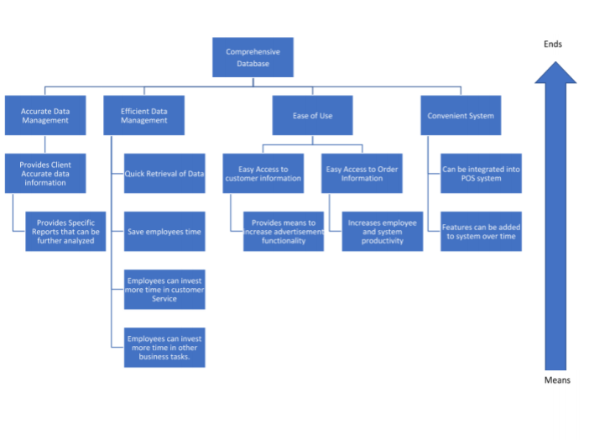

# Current Business Rule List

* If a customer buys any glass, their first fill is free.
* If a customer forgets their credit card, Klaus will close their tab and automatically charge 20% gratuity on the bill.
* Tables cannot be reserved unless the customer pre-purchases a package.
* On Thursdays, customers can bring in their own Stein for a free fill. However, the fill is limited to only one liter.
* If customers want to participate in any event (trivia, bingo, comedy night, or etc.), they must purchase at least one bier.
* Tokens can be exchanged for one pint of a core bier. Tokens do not have expiration dates.
* Customers can get gift sets (bundle’s) that are more discounted together then bought separately.

# Current Business Activity List

## Daily Taproom Activities

* Prepare Taproom for the day by following normal opening protocols
* Set up Beer Garden (including umbrellas and outside games)
* Serving Beer, wine, or soda to Customers
* Selling Merchandise: glasses, hats, shirts, or 22oz to-go bottles of any beer
* Informing Customers of where to get Klaus Beer from other Restaurants
* Interacting with food trucks
* Set up chalk boards with daily specials or events of the day
* Set up events (if any)
* Change out kegs if it becomes defective
* Shift Changes on Saturdays
* Do Laundry
* Wash glass periodically
* Clean tables as needed
* Close down Taproom and Garden by following normal closing protocols

Weekly Taproom Activities

* Inventory is taken
* Deep Clean taproom and beer garden following Sunday Deep Cleaning Checklist
* Manager Meetings (All managers and Owners)
* Sales Meetings (Sales Manager, Sales Team Members, Owners)
* Stein Night

Quarterly Taproom Activities

* Pest Control
* Quarterly Reports

Yearly Taproom Activities

* Oktoberfest
* Maifest
* Inspections
  + Safety Infections
  + TABC compliance audit
  + Mold Inspection
  + Equipment Inspection

# Current Event Response Table

|  |  |
| --- | --- |
| Event | Response |
| Prepare Taproom for the opening | Taproom managers and employees come in early to set up beer gardens, games, and set up chalk-boards with daily specials or events of the day. |
| Serving Customers | Biertenders choose what the customer requests via the POS system and charges the customer. Then hand the customers their paid items which could be Beer, wine, soda, or merchandise. |
| Customer inquires about food | Biertenders direct customers to Food Trucks available on the premises. |
| Event night | Biertenders and Taproom managers set up events. Then gives customers a countdown timer so they settle in and participate if they want. |
| Keg Changes | If kegs become defective, Kegs are switched out via the Bartenders or Taproom Manager. |
| Cleaning | Laundry, dishes, and cleaning is done periodically by Biertenders during business hours and at closing time. |
| Prepare Taproom for Close | Taproom Managers and Biertenders follow closing protocol to close down operations for the night. |
| Inventory | Mary-Lou takes inventory by checking on merchandise that she feels is subjectively low and needs to be ordered. |
| Deep Clean | Follow Sunday deep cleaning checklist |
| Manager Meetings | All managers and owners meet to discuss how Klaus Brewing will move forward on events and making profit. |
| Sales Meetings | The Sales team members, managers, along with the owners, come to discuss how to improve sales. |
| General Meetings | The owners and managers go over expectations for the week. |
| Stein Night | If customers bring their own stein, it is filled up by employees. |
| Quarterly Reports | Reports to show what Klaus Brewery has done in the previous months |
| Oktoberfest | Set up for the festival by preparing inventory, events, and food trucks. Make sure adequate advertisement is utilized. |
| Maifest | Set up for the festival by preparing inventory, events, and food trucks. Make sure adequate advertisement is utilized. |
| Inspections | Prepare the Taproom and Brewery for safety inspections and TABC compliance audits. Conduct Mold Inspections and Equipment Inspections to make sure productivity is not slowed down due to equipment failure or temporary taproom closing. |

# Current System Data Flow Diagram

## 

# Current Data Dictionary

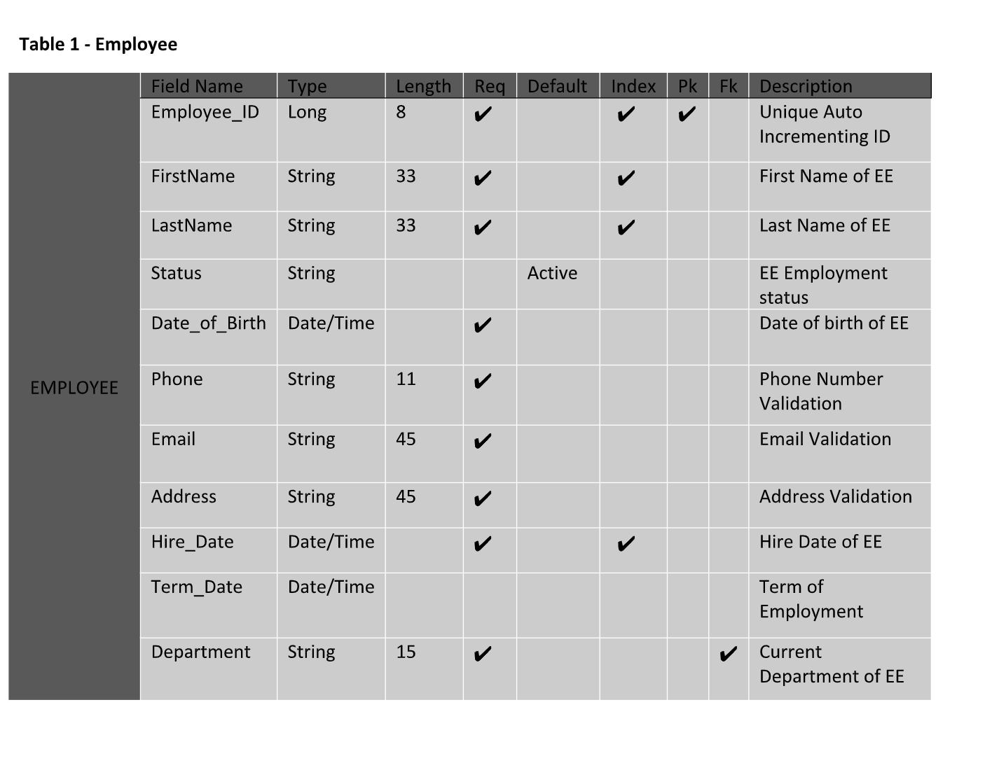

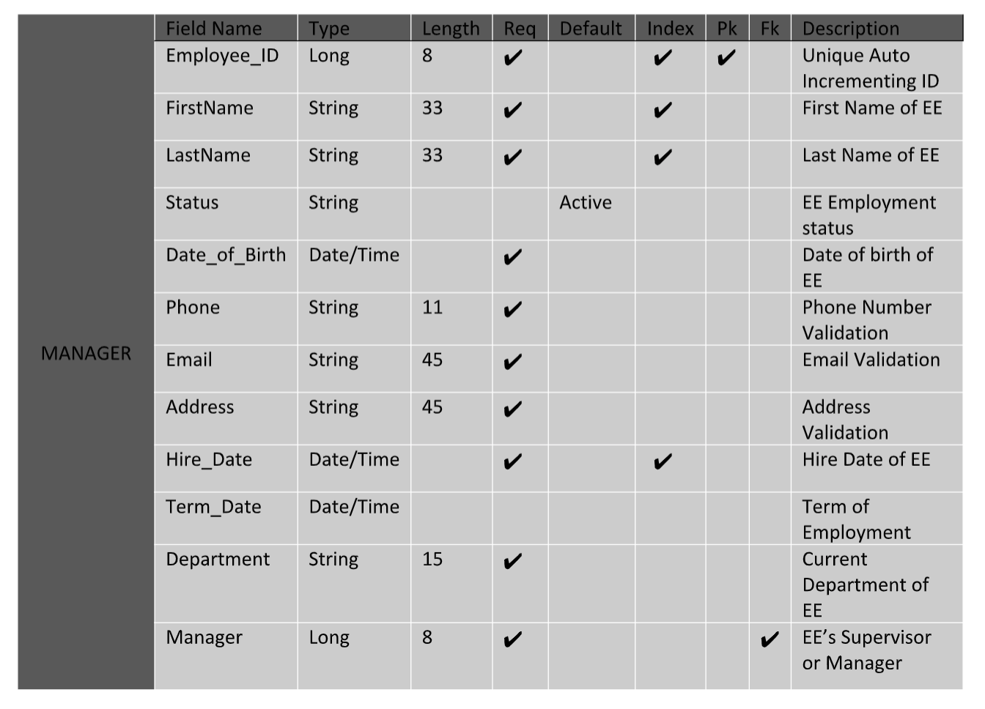

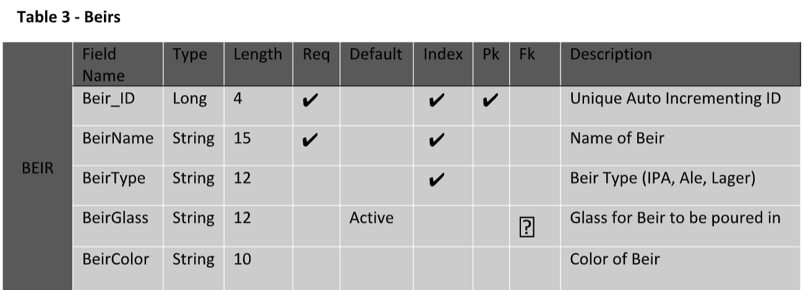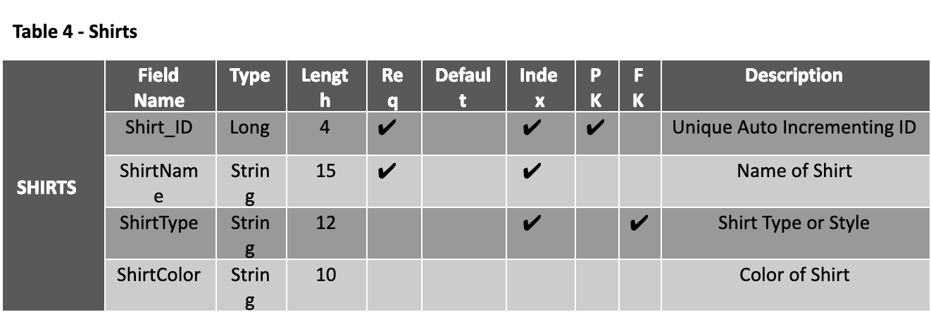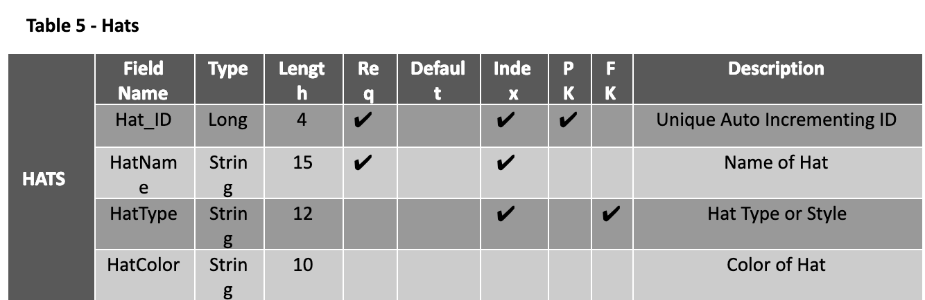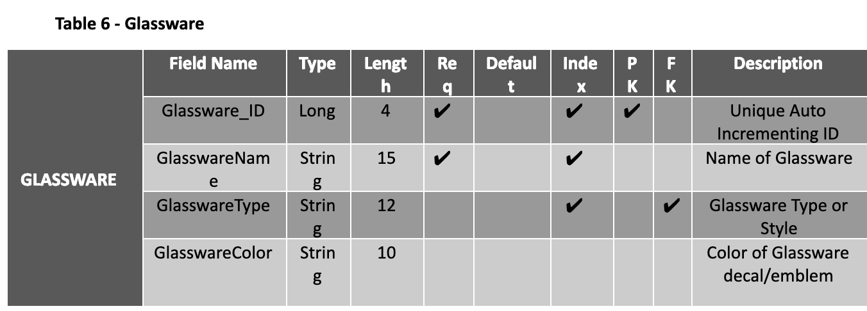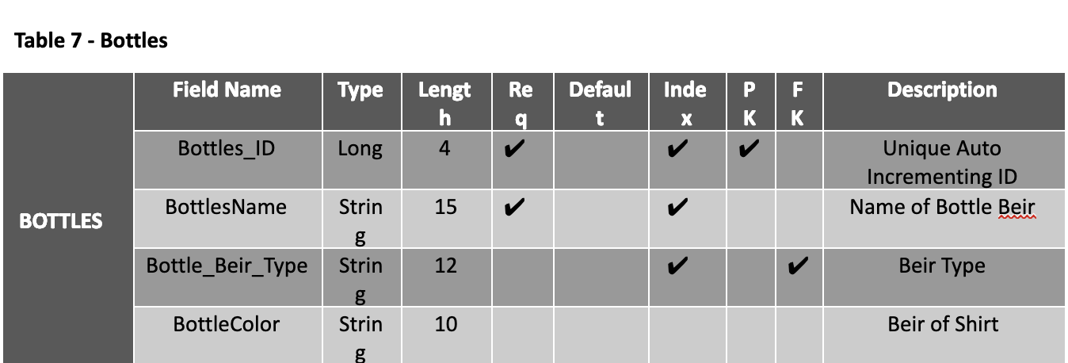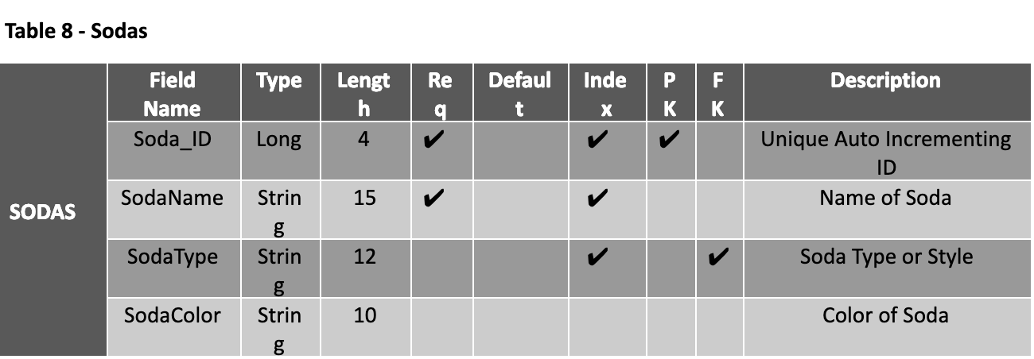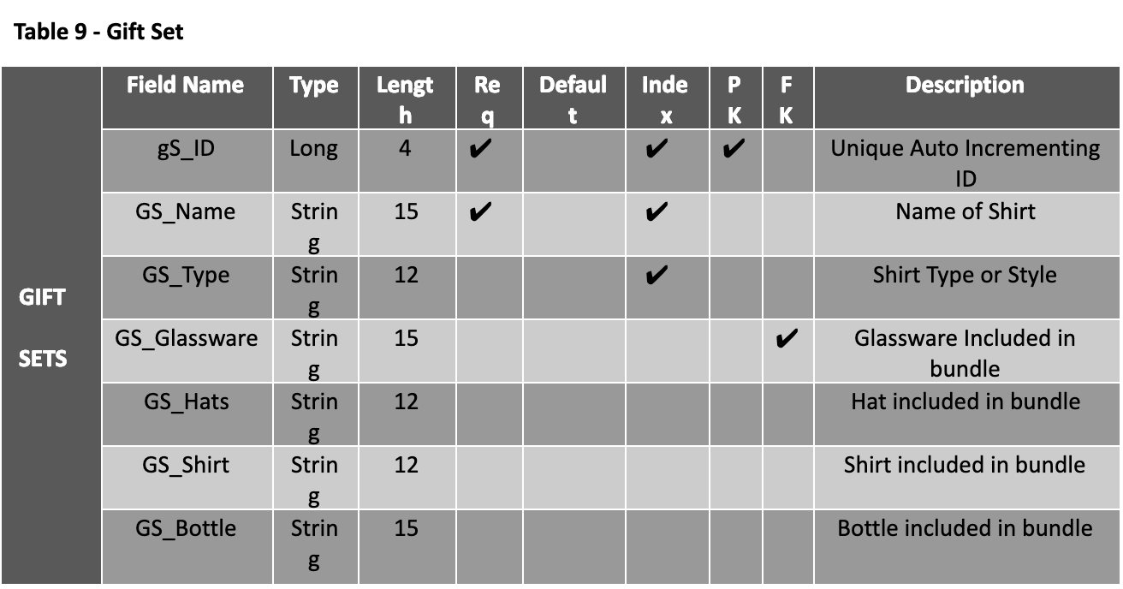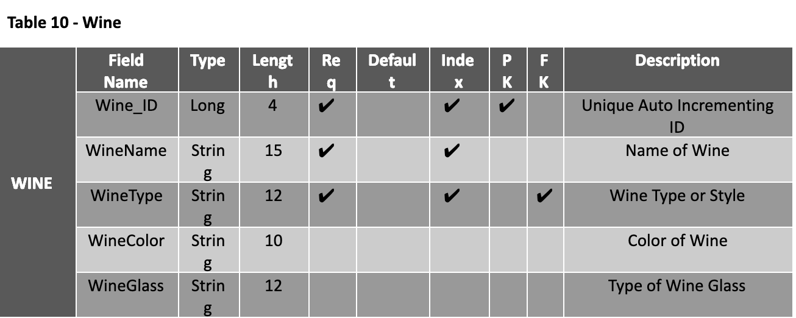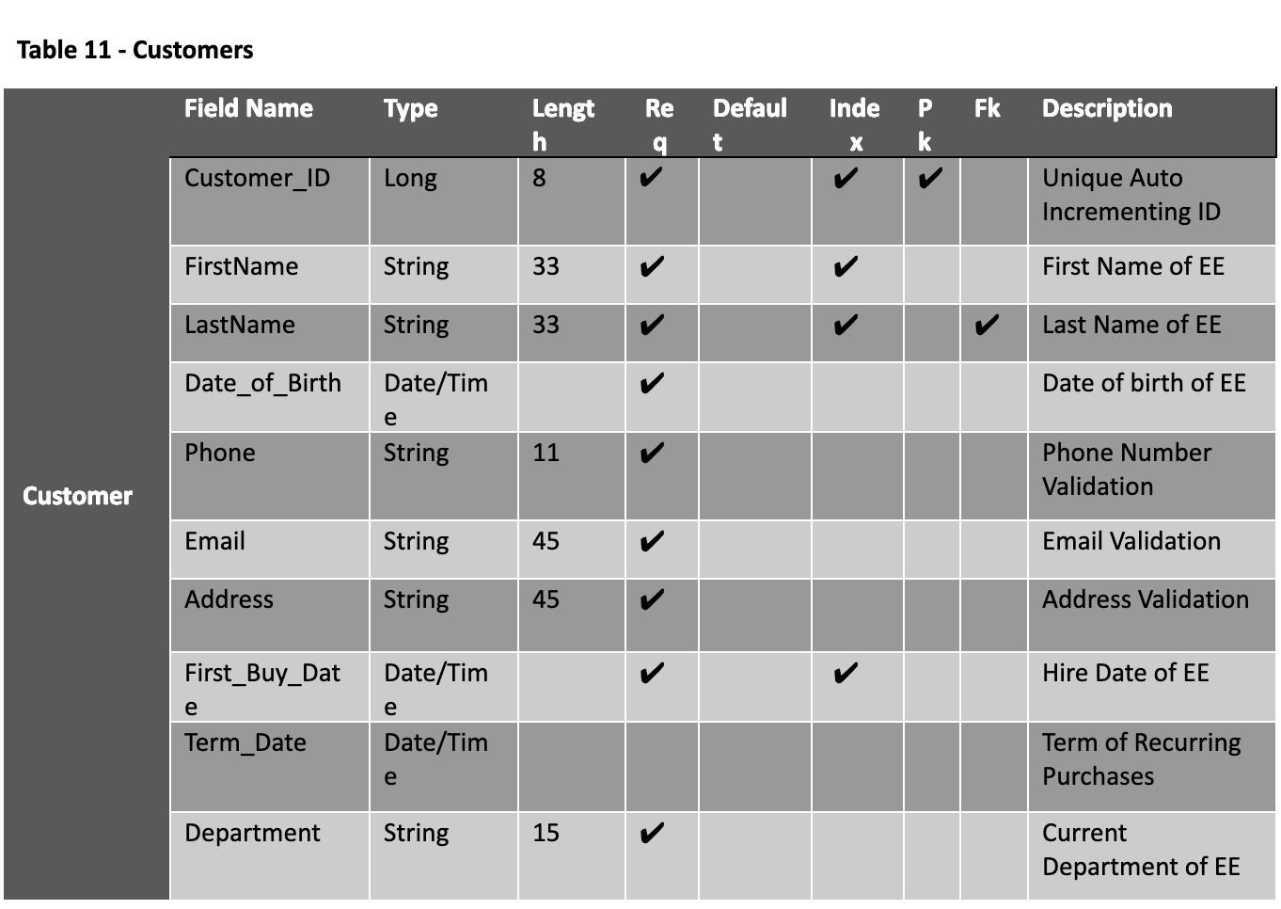

# Current Entity Relationship Diagram

## 

# Continued Updated Problems & Requirements List

|  |  |  |  |  |  |  |  |  |  |
| --- | --- | --- | --- | --- | --- | --- | --- | --- | --- |
| Ref Number | Problem Description | Source | Date | Priority (M, K, D) | Rank | Requirements Description | Current Perfor-mance (Excellent, Fair, Poor) | Required Perfor-mance | Scope ("in" or "out") |
| 2 | Upload spreadsheet form of merchandise and beir | Nahni | 02/16/2020 | M | 5 | Solution allows for uploading of current spreadsheets | P | E | In |
| 3 | Loyalty Program creation | Nandhi | 11/6/2019 | M | 7 | Solution allows for tables to be created depicting customer lastingness in brewery and what was purchased | F | E | In |
| 1 | Electronic access to resources | Nahni & Group | 02/10/20 | K | 1 | Create solution that allows company to access any forms, reports, customer info and order holdings online | P | E | In |
| 4 | Forms to handle customer profiles | Group & Nandhi | 02/16/2020 | K | 3 | Solution allows customer to input data and create profile from information | F | E | In |
| 6 | Pull up Customer Loyalty Report | Nandhi | 11/6/2019 | K | 4 | Solution allows ET to pull up any and all completed reports and tables of customer info related to purchased items | F | E | In |
| 5 | Live update of merchandise tracking | Nandhi | 02/16/2020 | D | 8 | Solution allows client to see up-to-date readings of merchandise and orders from client to customer. | P | F | In |
| 7 | Email notification of deals to Customers | Nandhi | 03/18/2020 | D | 8 | Solution allows for clients to send out email vouchers and deals, and give the customer the ability to sign up for a newsletter from the client. | F | P | Out |
| 8 | Inventory tracking | Owners/Nandhi | 02/15/2020 | M | 7 | Solution allows for client to track and record the inventory amount throughout the database, including all inventory items. | P | F | Out |

# Client SWOT Analysis





# Systems Proposal

Option 1

A system that creates an Order Processing system which itemizes merchandise including bier, glasses, gift sets, to-go bottles, sodas, wines, hats, and t-shirts. The system will then keep track of customer orders and purchases each day. The system will have the potential to grow as the new company grows which may include adding a shipping feature for their merchandise or integrating with a future inventory system. We are also proposing to create a system that will function as a database for customer data and relates it to how much money they spend, the merchandise they have purchased via the Order Processing system and how often they visit the Client’s site. This system will also hold information on how long the customer has been a member of Klaus Brewing Company. Data from the database system will assist in creating a loyalty program that rewards returning members’ incentives and benefits regarding the program. This system will be integrated into their POS system as their website so they can easily transition into using our system.

Option 2

A system that creates an Order Processing system which itemizes merchandise including bier, glasses, gift sets, to-go bottles, sodas, wines, hats, and t-shirts. The system will then keep track of customer orders and purchases each day. The system will have the potential to grow as the new company grows which may include adding a shipping feature for their merchandise or integrating with a future inventory system. We are also proposing to create a system that will function as a database for customer data and relates it to how much money they spend, the merchandise they have purchased via the Order Processing system and how often they visit the Client’s site. This system will also hold information on how long the customer has been a member of Klaus Brewing Company. Data from the database system will assist in creating a loyalty program that rewards returning members’ incentives and benefits regarding the program. This system will be a standalone system and will be integrated into their current POS system but not their website. This will be beneficial if they have to change their website database.

# Listing of Authors per Deliverable

* Table of Contents - John-Joshua Izuegbu

1. Team Members - John-Joshua Izuegbu
2. Client Memorandum of Agreement - Sean Tran
3. Team Communications Plan - Faryal Khan
4. Client Organization’s History/Background - John-Joshua Izuegbu and Sean Tran
5. Client Organization Timeline - Chantera Lazard and Pratik Asarpota
6. Client’s Organization Chart - Chantera Lazard and Sean Tran
7. Project Selection analysis - Chantera Lazard, John-Joshua, Faryal Khan(Contributor)
8. Initial Problem Statement - John Joshua
9. Problems and Requirements List - John-Joshua, Chantera Lazard
10. Scope Diagram - Pratik Aasarpota, Chantera Lazard
11. Data Gathering Goals - Faryal Khan
12. Data Gathering Methods - Chantera Lazard
13. Data Gathering Questions - Faryal Khan
14. Team Matrix - John-Joshua
15. Data Gathering Results - Sean Tran
16. Current System Description - Chantera Lazard
17. Current System Problem Description - Faryal Khan
18. Client Organization Objective List - John-Joshua Izuegbu
19. Client Applications(System)Objective List- Adekunle Kukoyi
20. Individual Users Objective List - Sean Tran
21. STROBE Analysis - Chantera Lazard, Adekunle Kukoyi and Faryal Khan
22. Samples of Records - Sean Tran
23. Initial Project Work Breakdown Structure - Sean Tran
24. Gantt Chart - Sean Tran
25. PERT Diagram - Sean Tran
26. Users/Stakeholders Analysis - Chantera Lazard
27. Initial Feasibility Analysis - John Joshua Izuegbu,Adekunle Kukoyi
28. Critical Requirements Analysis Objective Tree -
29. Current Business Rule List - Sean Tran and Chantera Lazard
30. Current Business Activity List - Chantera Lazard,Pratik Asarpota
31. Current Event Response Table - Adekunle Kukoyi and Chantera Lazard
32. Current System Data Flow Diagram - John-Joshua Izuegbu
33. Current Data Dictionary - John Joshua Izuegbu
34. Current Entity Relationship Diagram - Sean Tran
35. Client’s SWOT Analysis - Faryal Khan
36. System’s Proposal - Faryal Khan, Chantera Lazard, Sean Tran, John-Joshua, Adekunle Kukoyi
37. References - Faryal Khan , Chantera Lazard
38. Listing Of Authors - Faryal Khan
39. Binder - Chantera Lazard, John-Joshua
40. Powerpoint Presentation - Faryal Khan

# Sponsor’s Decision

Final Path Consulting designed this Project Charter to summarize our analysis of the problem presented to us and provide a summary of the proposed solution we have to offer Klaus Brewing Company. If our proposed solution is not approved, it allows Final Path Consulting to coordinate changes in a timely manner to meet our client’s requirements. If approved, we can move forward and complete the design of the application for this semester.

## Business Background

Klaus Brewing Company was founded by a local group of family and friends led by passionate brewer Thomas Lemke. Focused on bringing the under-served German-style beers to a wide range of consumers, from beer aficionados to new converts alike. They chose the name Klaus because they wanted a strong traditional German name. The name's meaning is "The People’s Victory". The company feels being able to offer people the ability to experience great locally crafted beer in a welcoming environment is truly a victory for everyone.

## Problem Statement

Our client, Klaus Brewing Company, has a few needs that they want to be implemented into their business. Their current client management program needs to be further completed and fortified. An ideal approach for the client would be that the client management program should have the ability to allow customers to feel as though they are the priority and to reward loyalty overtime. Second, the company would like to take advantage of the client information to also send advertisements and deals to their loyal customers. Third, their order processing system is out of date. They are able to receive orders, but they do not have the ability to track orders. The client would like an order processing system that tracks customer’s orders and eventually assigns it to the customer via the customer management program.

Our client will need a complex system that tracks orders and assigns it to a customer via an established client database. The system would also have to analyze these orders in a way to assist the company in creating a loyalty program for recurring customers as well as allow the company to send exclusive deals to their loyal customers.

## Proposed Solution

A system that creates an Order Processing system which itemizes merchandise including bier, glasses, gift sets, to-go bottles, sodas, wines, hats, and t-shirts. The system will then keep track of customer orders and purchases each day. The system will have the potential to grow as the new company grows which may include adding a shipping feature for their merchandise or integrating with a future inventory system. We are also proposing to create a system that will function as a database for customer data and relates it to how much money they spend, the merchandise they have purchased via the Order Processing system, and how often they visit the Client’s site. This system will also hold information on how long the customer has been a member of Klaus Brewing Company. Data from the database system will assist in creating a loyalty program that rewards returning members’ incentives and benefits regarding the program as well as give the company access to client information. This system will be a standalone system and will be integrated into their current POS system but not their website. This will be beneficial if they have to change their website database.

## High-Level Requirements

|  |  |  |  |
| --- | --- | --- | --- |
| # | Requirement Description | Source | Priority (HML) |
| 1 | Electronic Access to resources | Owners,Taproom Manager | M |
| 2 | Upload Spreadsheet form of merchandise and bier | Taproom Manager | H |
| 3 | Loyalty Program Creation | Taproom Manager | H |
| 4 | Forms to Handle Customer Profiles | Taproom Manager & Employees | M |
| 5 | Live Update of Merchandise Tracking | Nanhi | M |
| 6 | Customer Loyalty Report | Nanhi | M |
| 7 | Email Notification of Deals to Customers | Nanhi | L |

## Summary of Milestones & Deliverables

|  |  |  |
| --- | --- | --- |
| # | Milestone/Deliverable | Expected Completion Date  (subject to change based off unforeseen circumstances) |
| 1 | Charter | April 3, 2020 |
| 2 | Feasibility Analysis | April 4,2020 |
| 3 | Data Acquisition and Data Conversion Strategy | April 5, 2020 |
| 4 | Initial Draft of Testing Plan for Application and Database Creation | April 5, 2020 |
| 5 | Application Architecture Diagram | April 6, 2020 |
| 6 | Application Prototype | April 6, 2020 |
| 7 | Full Plan for System Design | April 14, 2020 |
| 8 | Start Designing Database | August 2020 |
| 9 | Complete Designing Database | December 2020 |
| 10 | Database Integration | January 2021 |

## 

## Initial Stakeholder Register & Agreement to Proceed

* All parties agree that the Charter reasonably reflects their understanding of the current situation, the defined problem & proposed solution, assumptions & constraints under which the team will operate, and the expected due dates for key deliverables;
* All parties understand that the project is a class exercise for a UH, College of Technology, Computer Information Systems undergraduate course which is intended, primarily, as a vehicle for teaching UH students about software development; and,
* Project Team members understand that they have an obligation to work with the client to deliver a ‘best effort’ MS Access product which satisfies both:
  + Client requirements (which will be defined in the Requirements Traceability Matrix),
  + Class requirements (as defined in the Project Requirements document);
* Client Sponsor authorizes the Project Team to begin working on a Statement of Scope, Work Breakdown Structure and Work Plan, which will provide an overall structure for managing the software development effort.

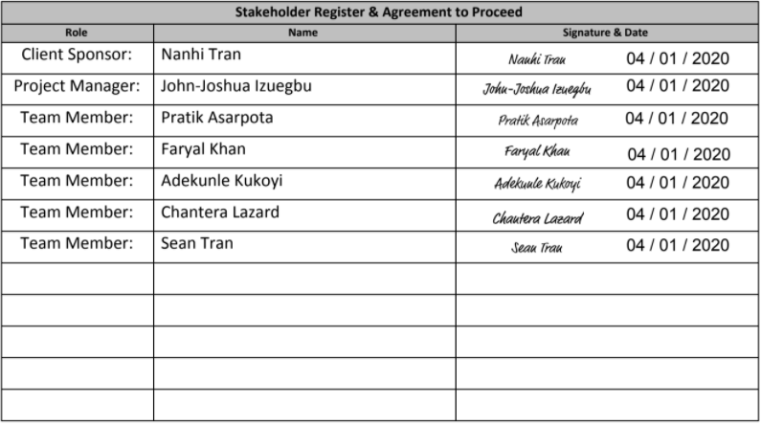

## 

# 

# Continued Updated Problem’s & Requirements List

|  |  |  |  |  |  |  |  |  |  |
| --- | --- | --- | --- | --- | --- | --- | --- | --- | --- |
| Ref Number | Problem Description | Source | Date | Priority (M, K, D) | Rank | Requirements Description | Current Perfor-mance (Excellent, Fair, Poor) | Required Perfor-mance | Scope ("in" or "out") |
| 2 | Upload spreadsheet form of merchandise and beir | Nahni | 02/16/2020 | M | 5 | Solution allows for uploading of current spreadsheets | P | E | In |
| 3 | Loyalty Program creation | Nandhi | 11/6/2019 | M | 7 | Solution allows for tables to be created depicting customer lastingness in brewery and what was purchased | F | E | In |
| 1 | Electronic access to resources | Nahni & Group | 02/10/20 | K | 1 | Create solution that allows company to access any forms, reports, customer info and order holdings online | P | E | In |
| 4 | Forms to handle customer profiles | Group & Nandhi | 02/16/2020 | K | 3 | Solution allows customer to input data and create profile from information | F | E | In |
| 6 | Pull up Customer Loyalty Report | Nandhi | 11/6/2019 | K | 4 | Solution allows ET to pull up any and all completed reports and tables of customer info related to purchased items | F | E | In |
| 5 | Live update of merchandise tracking | Nandhi | 02/16/2020 | D | 8 | Solution allows client to see up-to-date readings of merchandise and orders from client to customer. | P | F | In |
| 7 | Email notification of deals to Customers | Nandhi | 03/18/2020 | D | 8 | Solution allows for clients to send out email vouchers and deals, and give the customer the ability to sign up for a newsletter from the client. | F | P | Out |
| 8 | Inventory tracking | Owners/Nandhi | 02/15/2020 | M | 7 | Solution allows for client to track and record the inventory amount throughout the database, including all inventory items. | P | F | Out |
| 9 | Website Integration | Nanhi | 03/20/2020 | P | 5 | Solution allows for client to access the system through the company online website. | F | F | TBD |

# Required System Entity Relationship Diagram

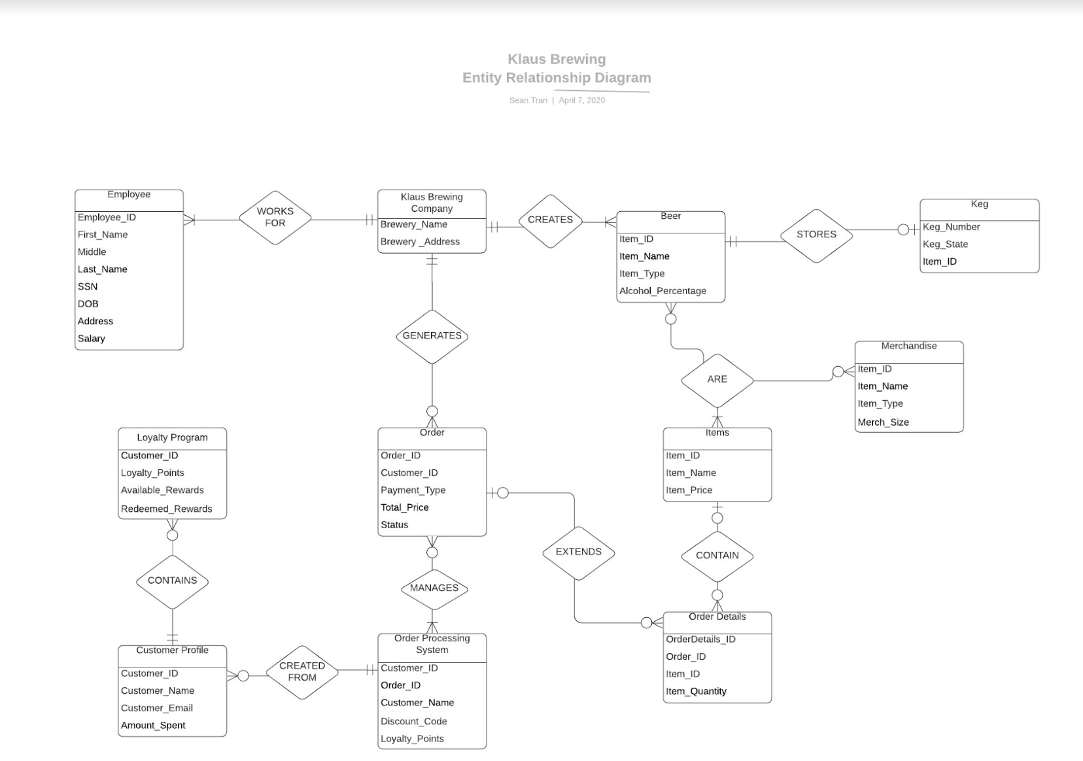

# Required System Business Rule List

* For each customer that comes in the brewery and makes a purchase, their purchase has to be recorded in their customer profile assigned to them according to the loyalty program.
* For each $7 that a customer spends, they recieve 1 point in their profile.
* Whenever a customer makes a purchase, whoever is working as a cashier at the moment is required to ask the customer for their email address or phone number and see some sort of photo id as well if the purchase regards any sort of alcohol.
* It's mandatory for employees to add customer purchases so they can later be awarded rewards programs later.
* For a customer that qualifies for a loyalty reward program, the cashier will ask them that they have an option whether to save their points for a bigger discount in the future or use the current points for a discount on the current day.
* If an employee returns any merchandise that they have purchased, it won’t affect their rewards points and points won’t be taken away from their customer profile.
* Employees are required to constantly update any sort of additional data or address changes to customers' profiles in the database.

## Required System Business Activity List

# Daily Taproom Activities

* Prepare Taproom for the day by following normal opening protocols
* Set up Beer Garden (including umbrellas and outside games)
* Requesting if customers are loyalty members or not
  + If a member, the taproom employees prompts the customer to login to their account via phone number or email address.
    - If the application is down, the taproom employees prompts the customer to keep the receipt and go online and login to the account. Add receipt number in a limited timeframe and the order would go against loyalty rewards.
  + If not a member, the taproom employees prompts the customer to go online and fill out a form to become a member.
    - If the application is down, the taproom employees prompt the customer to keep receipt and set up a profile later. Put the receipt number in in a limited timeframe and the order would go against loyalty rewards.
* Processing rewards if the customers have any.
* Serving Beer, wine, or soda to Customers
* Selling Merchandise: glasses, hats, shirts, or 22oz to-go bottles of any beer
* Informing Customers of where to get Klaus Beer from other Restaurants
* Interacting with food trucks
* Set up chalk boards with daily specials or events of the day
* Set up events (if any)
* Change out kegs if it becomes defective
* Shift Changes on Saturdays
* Do Laundry
* Wash glass periodically
* Clean tables as needed
* Close down Taproom and Garden by following normal closing protocols

# Weekly Taproom Activities

* Inventory is taken
* Deep Clean taproom and beer garden following Sunday Deep Cleaning Checklist
* Manager Meetings (All managers and Owners)
* Sales Meetings (Sales Manager, Sales Team Members, Owners)
* Stein Night
* Weekly Reports
* Send out weekly advertisements, promotions, and deals via email using client information

# Quarterly Taproom Activities

* Pest Control
* Quarterly Reports

# Yearly Taproom Activities

* Oktoberfest
* Maifest
* Inspections
  + Safety Infections
  + TABC compliance audit
  + Mold Inspection
  + Equipment Inspection

# 

# Required System CRUD Matrix

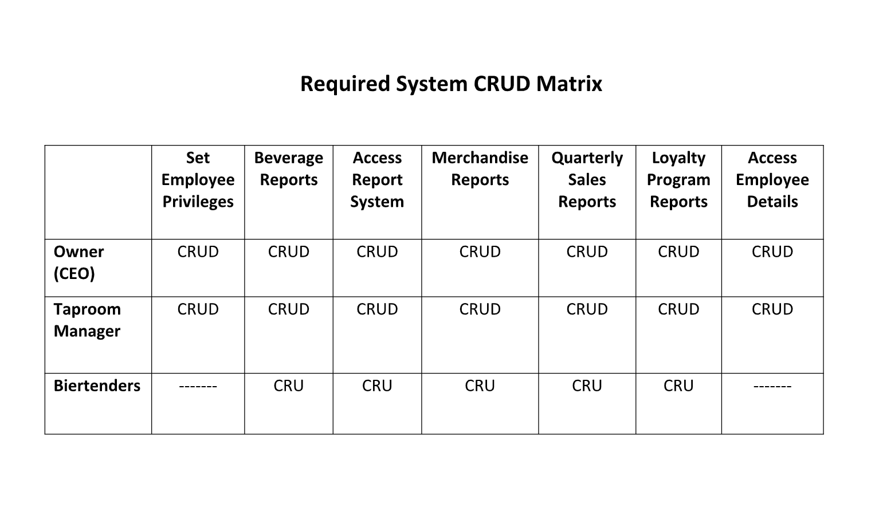

# Use Case Scenarios

Use case scenarios

Adekunle Kukoyi use cases:

|  |  |  |  |
| --- | --- | --- | --- |
| Use case name: Give customer access to information about Klaus Brewing products | | | |
| Area: Customer Management Information | | | |
| Actors: Customer, Final Path Application | | | |
| Stakeholder: Customer | | | |
| Level: indigo | | | |
| Description: After customer already has an account, and is logged into the account profile,  customer can find out about Klaus Brewing events and products by clicking on  the “information” button. | | | |
| Trigger: Customer is logged in and clicks the “information” button | | | |
| Trigger Type: ❑ External ☒ Internal | | | |
| Input | | Output | |
| Name | Source | Name | Destination |
| Customer Email  Customer password | Customer  Customer | New window to profile of customer  New window to Klaus Brewing website when “information” button is clicked | Customer  Customer |
| Steps Performed   1. Customer successfully logs into the Klaus Brewing account. 2. Customer clicks on the “information” button. | | Information for Steps   1. Type in Email, password and sent to new window 2. New window to Klaus Brewing official website | |
| Preconditions: Customer has an existing account | | | |
| Postconditions: Customer is able to log in | | | |
| Assumptions: Customer has a good browser | | | |
| Success Guarantee: Customer clicks on “information” button | | | |
| Minimum Guarantee: Customer logs in successfully | | | |
| Objectives Met: Customer is able to get to Klaus Brewing website for product and events  Information after clicking on “information” button | | | |
| Outstanding Issues: Is the button linked to Klaus Brewing website correctly? | | | |
| Priority (optional): medium | | | |
| Risk (optional): medium | | | |
|  | | | |

|  |  |  |  |
| --- | --- | --- | --- |
| Use case name: Final Path Application is down | | | |
| Area: Order processing | | | |
| Actors: Biertender, Customer | | | |
| Stakeholder: Biertender, Customer | | | |
| Level: indigo | | | |
| Description: Customer must keep receipts when tracking system is down and log-in later  to upload transaction receipts to get loyalty program tracked | | | |
| Trigger: Application for tracking customer ID through email or phone number is down | | | |
| Trigger Type: ❑ External √ Internal | | | |
| Input | | Output | |
| Name | Source | Name | Destination |
| Customer email  Customer password  Transaction receipt ID | Customer  Customer  Customer | New window after log-in  New window after “receipts upload” button is clicked  Confirmation on whether receipt ID was correct and uploaded | Customer  Customer  Customer |
| Steps Performed   1. Customer orders for a product. Biertender tells customer that tracking system is down. Customer is concerned for loyalty program. 2. Biertender tells customer to keep receipt and upload it on the website using the customer’s profile, when the tracking system is up and running again. 3. Customer goes back home and logs into the website when tracking system is back on. 4. Customer clicks on the button to that says “receipts upload’ to upload the transaction receipts. Customer uploads the receipt information. | | Information for Steps   1. Biertender takes order and enters it into the system 2. Biertender gives the customer the receipt and product.   3. Email and password needed  4. Receipt ID needed. Customer receives confirmation if the receipt ID is correct and has been uploaded. | |
| Preconditions: Customer has an account on the Klaus Brewing website | | | |
| Postconditions: Customer will log into the Klaus Brewing website | | | |
| Assumptions: Customer has a working browser and will keep the receipts carefully for  uploading later | | | |
| Success Guarantee: Customer was able to upload the receipt IDs successfully | | | |
| Minimum Guarantee: Customer was able to logon | | | |
| Objectives Met: Customer was able to upload receipt IDs so Klaus Brewing can track loyalty  program. | | | |
| Outstanding Issues: How long will the application that tracks customer ID be down?  Can this issue be resolved in less than a week? | | | |
| Priority (optional): high | | | |
| Risk (optional): high | | | |
|  | | | |

|  |  |  |  |
| --- | --- | --- | --- |
| Use case name: Customer is locked out of account | | | |
| Area: Customer Information Management | | | |
| Actors: Customer, Final Path Application | | | |
| Stakeholder: Customer | | | |
| Level: indigo | | | |
| Description: After the customer has tried to log in 3 times unsuccessfully, the customer is  locked out and prompted to click forgot password. | | | |
| Trigger: Customer forgets password and changes it by clicking forgot password | | | |
| Trigger Type: ☒ External ❑ Internal | | | |
| Input | | Output | |
| Name | Source | Name | Destination |
| Customer email or phone number  Customer Password  Phone number  Temporary password  New Password | Customer  Customer  Customer  Customer  Customer | Prompt to click “forgot password” button  Prompt to type in email to access password forgotten, or to type in phone number to receive email name  Prompt to type temporary password  Prompt to type in a new password | Customer  Customer  Customer  Customer  Customer |
| Steps Performed   1. Customer goes to Klaus Brewing website and tries to sign in 2. Customer tries to log in 3 times but fails 3. Customer clicks “forgot password” button 4. Customer does not remember email and chooses the “send email to phone number” option. Customer types in phone number. 5. Customer goes back to the forgot password option and types in email. 6. Customer types in temporary password and successfully logs in. 7. Customer clicks “update password’ button to change password | | Information for Steps   1. Email and password needed 2. Customer is prompted to click “forgot password” button 3. Customer is sent to a new window to type email to receive a temporary password, which also has a type in phone number option to receive email name, if forgotten. 4. Customeris sent the name of the email to the phone number associated with account. 5. Customer is sent temporary password to personal email if customer email was correct and exists in Klaus Brewing website records. New window is shown to enter temporary password received. 6. Customer will see an option to update password after logging in 7. New password will be typed twice and then updated to website records if they match | |
| Preconditions: Customer has made an account before | | | |
| Postconditions: Customer is able to follow the instructions to change password correctly | | | |
| Assumptions: Customer has a good browser with no issues | | | |
| Success Guarantee: Customer is able to successfully find out email and change password | | | |
| Minimum Guarantee: Customer clicks on “forgot password” button | | | |
| Objectives Met: Customer forgets email and password but is able to successfully change it | | | |
| Outstanding Issues: Will customer know to check junk for temporary password if not  seen in the inbox? | | | |
| Priority (optional): low | | | |
| Risk (optional): low | | | |
|  | | | |

Chantera Lazard use cases:

|  |  |  |  |
| --- | --- | --- | --- |
| Use case name: Creating a Customer Profile | | | |
| Area: Customer Information Management | | | |
| Actors: Primary: Customer Secondary: Final Path Consulting Web System | | | |
| Stakeholder: Customer- Interest: wants to create a profile to be able to benefit from customer loyalty program; Taproom Manager-Interest: How many total customers have been signing up for the program and utilizing the customer information | | | |
| Level: Blue | | | |
| Description: The customer creates a customer profile online by adding information to a form. The customer submits the form to complete creating a customer profile. | | | |
| Trigger: Customer wants to sign up for the loyalty program and goes online to initiate the process. | | | |
| Trigger Type: 🗹 External ❑ Internal | | | |
| Input | | Output | |
| Name | Source | Name | Destination |
| Password | Customer | Login page | Customer |
| Phone Number | Customer | Customer Profile Form | Customer |
| Email | Customer | Summary Page | Customer |
| Customer Name | Customer | Successful Profile Creation Message | Customer |
| Date of Birth | Customer |  |  |
| Steps Performed   1. Customer visits Klaus Brewing Company website and clicks on Sign up for Loyalty Program which will take the customer to a new application. 2. The customer will click the sign up button which will take the customer to sign up page. 3. Customer fills out the form completely and accurately. 4. Customer press submit which will move to a page summarizing the information. 5. The customer would verify the information and edit the form if any changes need to be made. 6. If no changes are to be made, the customer will press submit and a successful profile creation message will appear. | | Information for Steps   1. Sign up tab or button. 2. Login page which has a sign up option. 3. Customer Profile Form. 4. Summarizing page with edit button and submit button 5. Successful Profile Creation Message. | |
| Preconditions: Phone Number cannot be linked to another account. | | | |
| Postconditions: Customer Profile has been created. | | | |
| Assumptions: Customer has not signed up for the loyalty program before; Customer will provide accurate information. | | | |
| Success Guarantee: Information is saved in the client information management system. Email/Text message is sent to notify successful profile creation. | | | |
| Minimum Guarantee: Participants would be able to complete the customer profile but unable to submit successfully. | | | |
| Objectives Met: Allow recurring customers to be able to sign up for loyalty programs online using a secure Web application. | | | |
| Outstanding Issues: What happens if when trying to submit the phone number used is linked to another account? How do we verify if the customer’s phone number and email address is actually theirs? | | | |
| Priority (optional): | | | |
| Risk (optional): | | | |
|  | | | |

|  |  |  |  |
| --- | --- | --- | --- |
| Use case name: Login for Customer | | | |
| Area: Customer Information Management | | | |
| Actors: Primary: Customer Secondary: Final Path Consulting System | | | |
| Stakeholder: Customer | | | |
| Level: Indigo | | | |
| Description: Describes the process of the customer logging into their account | | | |
| Trigger: Customer wants to access their account and initiate the process by going to the sign in tab. | | | |
| Trigger Type: 🗹 External ❑ Internal | | | |
| Input | | Output | |
| Name | Source | Name | Destination |
| Username | Customer | Sign In page requesting username and password | Customer |
| Password | Customer | Access to account | Customer |
| Steps Performed   1. A customer goes to Klaus Brewing Company website and clicks the tab to access their Loyalty program account. 2. The customer provides their username and password. 3. The customer presses submit. | | Information for Steps   1. Tab on the main site that will reroute customers to the application. 2. Sign in page that prompts for username and password. 3. Submit button and access to their account if information is correct. | |
| Preconditions: Customer has an existing customer profile. | | | |
| Postconditions: Customer has access to their account. | | | |
| Assumptions: Customer knows valid username and password. Customer accessing the account is the customer who originally signed up for the account. | | | |
| Success Guarantee: Customer successfully accessed customer profile. | | | |
| Minimum Guarantee: Customer did not provide their correct username/password combination and an error message will appear. | | | |
| Objectives Met: Customer was able to login to the system to access their account. | | | |
| Outstanding Issues: What if the customer forgets their username or password? What if the customer tries too many times to sign into account? | | | |
| Priority (optional): | | | |
| Risk (optional): | | | |
|  | | | |

|  |  |  |  |
| --- | --- | --- | --- |
| Use case name: Updating a Customer Profile | | | |
| Area: Customer Information Management | | | |
| Actors: Primary: Customer Secondary: Final Path Consulting Application | | | |
| Stakeholder: Customer: Updated information to receive deals Taproom Manager: Updated Information to send deals. | | | |
| Level: Blue | | | |
| Description: The customer updates customer profile information after using the login use-case | | | |
| Trigger: Customer information has changed and they want to update information on their profile. Customer login to customer profile to start process. | | | |
| Trigger Type: 🗹 External ❑ Internal | | | |
| Input | | Output | |
| Name | Source | Name | Destination |
| Updated Phone Number | Customer | Edit option for Customer Information | Customer |
| Updated email address | Customer | My account page | Customer |
| Updated Address | Customer | Edit form | Customer |
| Steps Performed   1. After customer logins to the web application, they go to my account information. 2. They click on edit information. 3. They edit information that needs to be updated which should only include their email address, phone number, or address. 4. They submit edits after verifying information is correct. | | Information for Steps   1. My account button. 2. An option to edit. 3. Edit form that allows customers to update corresponding information. 4. submit button. 5. An “my account page” that shows updated information. | |
| Preconditions: Customer successfully completed login use case. | | | |
| Postconditions: Customer successfully updates profile information. | | | |
| Assumptions: Customer accurately updates information. | | | |
| Success Guarantee: Customer successfully updates information and the information is updated on the account page. | | | |
| Minimum Guarantee: Customer logins to account. | | | |
| Objectives Met: Allowing customers to update their customer profile information. | | | |
| Outstanding Issues: How can we limit the information the customer can edit? What if the updated information is linked to another account? How can we verify new information? | | | |
| Priority (optional): | | | |
| Risk (optional): | | | |
|  | | | |

Pratik Asarpota use cases:

|  |  |  |  |
| --- | --- | --- | --- |
| Use case name: Customer purchasing tokens which can be exchanged for core biers | | | |
| Area: Klaus Brewery serving area | | | |
| Actors: Customer, Biertender | | | |
| Stakeholder: Customer | | | |
| Level: Blue | | | |
| Description: Customer purchases tokens | | | |
| Trigger: Customer decides to purchase tokens in order to exchange for exclusive core biers | | | |
| Trigger Type: ✔ External ❑ Internal | | | |
| Input | | Output | |
| Name | Source | Name | Destination |
| Customer credentials,  Employee takes customer order | Customer | Employee provides customer with appropriate number of tokens | Customer |
| Steps Performed   1. Employee takes customer credentials 2. Employee informs customers about tokens and the benefits 3. Customer would like to purchase tokens 4. Employee sets payment option as tokens 5. Customer purchases tokens with cash 6. Customer exchanges token for core bier | | Information for Steps   1. Credentials needed 2. Employee provides information to customer regarding tokens as payment option for core biers 3. Menu of core biers is shown 4. Employee sets payment option to tokens in system and customer purchases tokens 5. Exchange tokens for bier | |
| Preconditions: Customer wants to purchase tokens | | | |
| Postconditions: Customer exchanges them for core biers | | | |
| Assumptions: Customer has never used tokens to exchange for core biers | | | |
| Success Guarantee: Employee informs customer that tokens allow them to try exclusive core biers | | | |
| Minimum Guarantee: Customer purchases bier or other merchandise | | | |
| Objectives Met: Provide customer with a new experience which allows them to try new biers | | | |
| Outstanding Issues: Will customer be interested in purchasing tokens to try exclusive biers? | | | |
| Priority (optional): | | | |
| Risk (optional): | | | |
|  | | | |

|  |  |  |  |
| --- | --- | --- | --- |
| Use case name: Customer purchasing merchandise | | | |
| Area: Klaus Brewery serving area | | | |
| Actors: Customer, Employee | | | |
| Stakeholder: Customer | | | |
| Level: Blue | | | |
| Description: Allow customer to choose and purchase from a variety of merchandise | | | |
| Trigger: Customer decides to purchase merchandise | | | |
| Trigger Type: ✔ External ❑ Internal | | | |
| Input | | Output | |
| Name | Source | Name | Destination |
| Customer credentials,  Employee takes customer order | Customer | Employee provides a list of all available merchandise,  Customer receives order | Customer |
| Steps Performed   1. Employee informs customers about the variety of available merchandise 2. Customer looks through list of and adds items to order 3. Employee takes customer credentials 4. Customer gets loyalty program points after purchase | | Information for Steps   1. Employee educates customer on the different kinds of merchandise – clothing, hats, beer mugs, keychains, etc. 2. Customer is shown merchandise 3. Employee inserts customer credentials into system 4. Customer makes the purchase and receives reward points in their account | |
| Preconditions: Customer has an existing account and would like to purchase merchandise | | | |
| Postconditions: Customer receives order of merchandise | | | |
| Assumptions: Customer is interested in purchasing merchandise either as souvenir or as a present | | | |
| Success Guarantee: Employee is able to find customer’s exact need of merchandise | | | |
| Minimum Guarantee: Customer’s selection is not found, and employee educates customer on all the different merchandise available to purchase | | | |
| Objectives Met: Provide customer with knowledge about different products available apart from beverages | | | |
| Outstanding Issues: Will customer be interested in purchasing any merchandise? | | | |
| Priority (optional): | | | |
| Risk (optional): | | | |
|  | | | |

|  |  |  |  |
| --- | --- | --- | --- |
| Use case name: Management requests Loyalty Program Report | | | |
| Area: Klaus Brewery Management Office | | | |
| Actors: Manager, Employee | | | |
| Stakeholder: Employee, Manager, Owner | | | |
| Level: Indigo | | | |
| Description: Manager requests employees to show loyalty program report which will be used to create the loyalty for customers | | | |
| Trigger: Management would like to go over and study the loyalty program report | | | |
| Trigger Type: ✔ External ❑ Internal | | | |
| Input | | Output | |
| Name | Source | Name | Destination |
| Manager requests to see loyalty program report | Employee | Manager receives loyalty program report | Manager |
| Steps Performed   1. Manager requests employees to send loyalty program report 2. Employee logs into database using their credentials 3. Employee goes to Reports Tab and finds loyalty program report 4. Employee sends the report to the Manager | | Information for Steps   1. Employee has access to report system in the database 2. Employee has created first level report for loyalty program 3. Employee has ability to customize and send the report to the manager | |
| Preconditions: Employee has created/started to create loyalty program report | | | |
| Postconditions: Employee created report and gave it to the manager | | | |
| Assumptions: Employee has access to report system in the database | | | |
| Success Guarantee: Report framework is created | | | |
| Minimum Guarantee: A report will be created | | | |
| Objectives Met: Loyalty system for customers will be created using report | | | |
| Outstanding Issues: Report has not been created, or is improperly formatted or incomplete | | | |
| Priority (optional): | | | |
| Risk (optional): | | | |
|  | | | |

Sean Tran’s use cases:

|  |  |  |  |
| --- | --- | --- | --- |
| Use case name: Customer wants to check their loyalty program points and possible rewards | | | |
| Area: Klaus Loyalty Program | | | |
| Actors: Customer | | | |
| Stakeholder: Customer | | | |
| Level: Blue | | | |
| Description: Allow customer to identify the amount of loyalty program points they have available. | | | |
| Trigger: Customer uses Klaus loyalty program application and clicks Loyalty Program tab. | | | |
| Trigger Type: 🗹 External ❑ Internal | | | |
| Input | | Output | |
| Name | Source | Name | Destination |
| Username  Password | Customer  Customer | Sign in page that requests user/pw.  Loyalty Program rewards | Customer  Customer |
| Steps Performed   1. Customer visits Klaus Brewing company website and clicks on Loyalty Program tab. 2. Customer provides username and password in order to log in. 3. Customer clicks Rewards tab. 4. Customer can view the amount of points they have. | | Information for Steps   1. Loyalty Program tab will reroute customers to the Final Path application. 2. Sign in page will request login credentials from customer. 3. Will take customer to rewards catalog. 4. If the reward is greyed out/unclickable, the customer does not have sufficient amount of points. | |
| Preconditions: Customer already has an account with Klaus Brewing. | | | |
| Postconditions: Customer has access to their account. | | | |
| Assumptions: Customer has access to browser and their email. | | | |
| Success Guarantee: Customer successfully views rewards and their points. | | | |
| Minimum Guarantee: Customer has access to their Klaus Brewing account. | | | |
| Objectives Met: Customer is motivated to spend more money at Klaus Brewing in order to rack up points to spend on rewards. | | | |
| Outstanding Issues: What if the customer is able to redeem a reward that they are illegible for? What if the customer forgets their login credentials? | | | |
| Priority (optional): | | | |
| Risk (optional): | | | |
|  | | | |

|  |  |  |  |
| --- | --- | --- | --- |
| Use case name: Customer reward redemption | | | |
| Area: Klaus Loyalty Program | | | |
| Actors: Customer, Taproom Manager | | | |
| Stakeholder: Customer | | | |
| Level: Blue | | | |
| Description: Allow customer to redeem loyalty points in exchange for a reward | | | |
| Trigger: Redeem reward button in loyalty program section of customer account | | | |
| Trigger Type: ❑ External 🗹 Internal | | | |
| Input | | Output | |
| Name | Source | Name | Destination |
| Username  Password | Customer  Customer | Sign in page that requests username and password  Loyalty Program rewards | Customer  Customer |
| Steps Performed   1. Customer visits Klaus Brewing Company website and clicks on Loyalty Program tab. 2. Customer provides username and password in order to log in. 3. Customer clicks on Rewards tab. 4. Customer clicks a reward they are eligible for. 5. Customer clicks Redeem reward button. | | Information for Steps   1. Loyalty Program tab will reroute customers to the Final Path application. 2. Sign in page will request login credentials from customer. 3. Will take customer to rewards catalog. 4. Different rewards worth various amounts of points will be displayed. 5. Redeem reward button will send reward certificate to customer’s email. | |
| Preconditions: Customer has an existing customer account with Klaus Brewing. | | | |
| Postconditions: Customer is able to redeem their loyalty points for rewards. | | | |
| Assumptions: Customer has loyalty points and a valid username and password. | | | |
| Success Guarantee: Customer successfully redeems their points and will receive a discount/reward the next time they visit Klaus Brewing. | | | |
| Minimum Guarantee: Customer is able to log in and check how many loyalty points they have. | | | |
| Objectives Met: Customer has incentive to spend more at Klaus Brewing and return to the establishment. | | | |
| Outstanding Issues: What if customer is able to click on a reward they are illegible for? | | | |
| Priority (optional): | | | |
| Risk (optional): | | | |
|  | | | |

|  |  |  |  |
| --- | --- | --- | --- |
| Use case name: Employee adds new loyalty program rewards | | | |
| Area: Klaus Brewing Loyalty Program | | | |
| Actors: Employee | | | |
| Stakeholder: Employee, Customer | | | |
| Level: Indigo | | | |
| Description: Employee has new rewards that they would like to add for Klaus loyalty program members. | | | |
| Trigger: Employee clicks Submit in loyalty program management. | | | |
| Trigger Type: √ External ❑ Internal | | | |
| Input | | Output | |
| Name | Source | Name | Destination |
| Username  Password | Employee  Employee | Loyalty Program Reward | Customer |
| Steps Performed   1. Employee logs into Klaus Brewing application. 2. Employee clicks on Loyalty Program tab. 3. Employee clicks on Edit Rewards button 4. Employee inputs details of new reward. 5. Employee clicks submit button | | Information for Steps   1. Employee will be prompted to input username and password 2. Employee will be rerouted to Final Path application. 3. This button will only be available for employees. 4. Name of reward, point cost, etc. 5. Confirmation page | |
| Preconditions: Employee has an existing account with Klaus Brewing. | | | |
| Postconditions: Employee successfully adds a new reward to loyalty program. | | | |
| Assumptions: Employee has a valid username and password. | | | |
| Success Guarantee: Employee successfully edits the loyalty program rewards and it is visible to loyalty program members. | | | |
| Minimum Guarantee: Employee is able to access their account. | | | |
| Objectives Met: Employee has the ability to edit loyalty program rewards to keep members interested in spending more and visiting Klaus more. | | | |
| Outstanding Issues: What if the employee does not have access to their account? What if a mistake to a reward is made and a customer redeems it? | | | |
| Priority (optional): | | | |
| Risk (optional): | | | |
|  | | | |

Faryal khan’s use cases:

|  |  |  |  |
| --- | --- | --- | --- |
| Use case name: A customer places an order for red wine | | | |
| Area: Klaus brewery serving area | | | |
| Actors: bartender and Klaus brewery customer | | | |
| Stakeholder: Bartender, customer, Taproom shift lead | | | |
| Level: indigo | | | |
| Description: After a customer places an order | | | |
| Trigger: The customer decides he wants to buy the red wine. | | | |
| Trigger Type: ❑ External Checkmark Internal | | | |
| Input | | Output | |
| Name | Source | Name | Destination |
| Bartender gets order from customer | Customer uses menu | Customer gets his desired wine | Customer |
| Steps Performed   1. Customer looks at selection of wine available for purchase 2. Customer chooses wine as a selection. 3. Customer calls Bartender 4. Customer tells Bartender what wine he wants. 5. Bartender takes his order. | | Information for Steps   1. Menu for wines 2. Menu for wines 3. Customer identifies bartender and calls him 4. Bartender notices customer and goes to him. 5. Bartender notes down order on notepad and goes to get wine. | |
| Preconditions: Customer needs to see selection of wines available for his purchase | | | |
| Postconditions: Customer receives his order | | | |
| Assumptions: bartender finds customer’s selection and brings it to the customer. | | | |
| Success Guarantee: Customers selected wine is found and brought to customer | | | |
| Minimum Guarantee: Customers selected wine is not found and bartender informs him. | | | |
| Objectives Met: Allow customers to place an order after looking at menu | | | |
| Outstanding Issues: What if the customer’s wine is not available? | | | |
| Priority (optional): medium | | | |
| Risk (optional): low | | | |
|  | | | |

|  |  |  |  |
| --- | --- | --- | --- |
| Use case name: Biertender changes out kegs with a replacement once they become defected | | | |
| Area: Klaus brewery serving area | | | |
| Actors: Biertender | | | |
| Stakeholder: Biertender, customer | | | |
| Level: Indigo | | | |
| Description: After a keg goes bad(if it tastes bad or has cloudy appearance), biertender changes the keg | | | |
| Trigger: The biertender checks beer inside keg and finds out it has gone bad | | | |
| Trigger Type: ❑ External Checkmark Internal | | | |
| Input | | Output | |
| Name | Source | Name | Destination |
| Biertender checks keg,  Biertender goes to get a replacement | Keg | New Keg is placed instead of old one | Klaus brewery |
| Steps Performed   1. Biertender checks the keg to make sure that beer is not defected. 2. She finds out its defected. 3. She then gets another keg. 4. She replaces old keg with new keg. 5. She takes defected keg with her. | | Information for Steps   1. Biertender knows how to check the keg. 2. She knows what a defected keg looks like. 3. She knows where to find replacement from. 4. She knows how to change it 5. She knows where to throw old keg away. | |
| Preconditions: Biertender has checked keg and found it to be defaulted | | | |
| Postconditions: Biertender changes defected keg with a new one. | | | |
| Assumptions: Biertender is capable of realizing a defected keg and then knows where replacement of that keg is. | | | |
| Success Guarantee: Biertender finds out that keg is defected and is able to replace it with a replacement of a new non defected keg. | | | |
| Minimum Guarantee: Biertender removes the defected keg. | | | |
| Objectives Met: Allows biertender to realize that keg is defected and find a non-defected replacement. | | | |
| Outstanding Issues: What if replacement for the defected keg is not available? | | | |
| Priority (optional): high | | | |
| Risk (optional): high | | | |
|  | | | |

|  |  |  |  |
| --- | --- | --- | --- |
| Use case name: Employee checks if a customer is eligible for rewards through loyalty program | | | |
| Area: Klaus brewery serving area | | | |
| Actors: Taproom shift lead | | | |
| Stakeholder: Taproom shift lead, customer | | | |
| Level: Indigo | | | |
| Description: Taproom shift lead checks if a customer is qualified for a discount. | | | |
| Trigger: Customer has just made a purchase and since they are a returning customer, they are checking what discounts are they eligible for. | | | |
| Trigger Type: ❑ External CheckmarkInternal | | | |
| Input | | Output | |
| Name | Source | Name | Destination |
| Employee’s info, customers credentials like name, email or phone number | Computer System | Discounts that customer is available for | Computer System |
| Steps Performed   1. Customer has just purchased a shirt. 2. Taproom shift lead is on counter and assists customer with purchase. 3. Customer asks that they are a returning customer and are they eligible for some sort of discount. 4. Shift lead logs in to the computer, asks for customer’s email or phone number. 5. Customer tells them their credentials and then looks at customer’s profile on the computer. | | Information for Steps   1. Customer gives shirt to shift lead. 2. Shift lead asks customer if they need any additional assistance. 3. Customer gives their name and asks what discount they can use. 4. Employee’s credentials, customer’s email or phone. 5. Customer’s email or phone number and employee should know how to use the system. | |
| Preconditions: Employee needs to access the system to check customer’s eligibility | | | |
| Postconditions: Employee tells customer what discounts they are eligible for | | | |
| Assumptions: Employee is capable of logging in to system and find customers profile to check how many points are available for customer | | | |
| Success Guarantee: Employee informs customer that they have certain number of points available and discount available for them. | | | |
| Minimum Guarantee: Employee cannot check the system and can’t find out customer’s eligibility for a discount. | | | |
| Objectives Met: Allows employee to find customers profile and see what discounts are they eligible for. | | | |
| Outstanding Issues: What if employee cant find customers profile? | | | |
| Priority (optional): high | | | |
| Risk (optional): medium | | | |
|  | | | |

John-Joshua Izuegbu’s use cases:

|  |  |  |  |
| --- | --- | --- | --- |
| Use case name: Login for Employee (Manager) | | | |
| Area: Order Processing System | | | |
| Actors: Employee | | | |
| Stakeholder: Employee, Customer, Taproom System | | | |
| Level: | | | |
| Description: Employee Logs into system | | | |
| Trigger: Employee presses “Submit” | | | |
| Trigger Type: ✔ External ❑Internal | | | |
| Input | | Output | |
| Name | Source | Name | Destination |
| Employee logs into system | Employee uses username and password | Employee gains access to system | Opening menu of system is initialized and displayed |
| Steps Performed   1. Employee clicks on username. 2. Employee types in personal username. 3. Employee clicks password. 4. Employee types personal password. 5. Employee clicks “Submit”. | | Information for Steps   1. Employee ID/Username, Password 2. Employee Record 3. Employee ID/Username, Password 4. Employee Record 5. Validation of Record, Conformation | |
| Preconditions: Employee is on the Login Screen | | | |
| Postconditions: Employee has logged in successfully to the system | | | |
| Assumptions: Employee knows valid Username and Passwords | | | |
| Success Guarantee: Login in was successful and see employee screen | | | |
| Minimum Guarantee: Error message is shown for improper input of Username/Password | | | |
| Objectives Met: Logged in to system | | | |
| Outstanding Issues: What if credentials are forgotten and need reset? | | | |
| Priority (optional): | | | |
| Risk (optional): | | | |
|  | | | |

|  |  |  |  |
| --- | --- | --- | --- |
| Use case name: Creating First Level Report for Loyalty Program Reports | | | |
| Area: Reports area of Order Processing System | | | |
| Actors: Manager, Accounts Manager | | | |
| Stakeholder: Manager, Owners, Accounts Manager | | | |
| Level: | | | |
| Description: Queue up Reports for Loyalty Program | | | |
| Trigger: Employee clicking “Make Report” | | | |
| Trigger Type: ❑ External ✔Internal | | | |
| Input | | Output | |
| Name | Source | Name | Destination |
| Employee Creates 1st level Report | Employee open report query section in the database | Employee created 1st Level Report for Loyalty System | Outline for loyalty program |
| Steps Performed   1. Employee goes to Reports Tab 2. Employee clicks and defines query results 3. Employee sets up parameters for loyalty program 4. Employee chooses Time and Sales table 5. Employee chooses Customer table 6. Employee Runs Report | | Information for Steps   1. Employee Sets up customer names view. 2. Employee sets up customer longevity view. 3. Employee sets up customer profitability view. 4. Employee edits for time frame 5. Employee has ability for customization for other products. | |
| Preconditions: Employee begins to create framework for loyalty program population | | | |
| Postconditions: Employee create formatted Customer Report | | | |
| Assumptions: Employee has access to Report system in database | | | |
| Success Guarantee: Report framework is created | | | |
| Minimum Guarantee: A Report will be created | | | |
| Objectives Met: Loyalty system is created from reports | | | |
| Outstanding Issues: What is reports are improperly formatted or queued. | | | |
| Priority (optional): | | | |
| Risk (optional): | | | |
|  | | | |

|  |  |  |  |
| --- | --- | --- | --- |
| Use case name: Fill out Employee Form | | | |
| Area: Order Processing System, Employee Table | | | |
| Actors: Employee | | | |
| Stakeholder: Employee(s) | | | |
| Level: | | | |
| Description: Employee Adds in employee information to form for database profile | | | |
| Trigger: Employee submits form | | | |
| Trigger Type: ✔ External ❑ Internal | | | |
| Input | | Output | |
| Name | Source | Name | Destination |
| Employee Fills Form | Employee Form Window | Employee Profile Submitted | Employee Profile submitted and placed in database |
| Steps Performed   1. Employee Clicks “Fill out form” 2. Employee fills out Employee ID. 3. Employee fills out first name 4. Employee fills out last name. 5. Employee fills out phone number 6. Employee fills out email. 7. Employee fills out address. 8. Employee fills out Start Date. 9. Employee fills out Position. 10. Employee clicks “Submit”. | | Information for Steps   1. Employee Profile submitted with button press. 2. Conformation of submission is stated and displayed. 3. Employee is guided to next screen/step. | |
| Preconditions: Employee wants to create profile | | | |
| Postconditions: Employee has created profile | | | |
| Assumptions: Employee knows his personal information | | | |
| Success Guarantee: Employee profile is created and placed in database | | | |
| Minimum Guarantee: Employee name is submitted | | | |
| Objectives Met: Employee profile is populated with Employee data | | | |
| Outstanding Issues: Employee might input improper data. | | | |
| Priority (optional): | | | |
| Risk (optional): | | | |
|  | | | |

# 

# Required Event Response Table

|  |  |
| --- | --- |
| Event | Response |
| Prepare Taproom for the opening | Taproom managers and employees come in early to set up beer gardens, games, and set up chalk-boards with daily specials or events of the day. |
| Serving Customers | Biertenders ask customers for their phone number or email so that the customer’s purchase can be tracked by the application provided by finalpath, for the loyalty program. Then biertenders choose what the customer requests via the POS system and charges the customer. Then hands the customers their paid items which could be Beer, wine, soda, or merchandise. |
| Customer inquires about food | Biertenders direct customers to Food Trucks available on the premises. |
| Event night | Biertenders and Taproom managers set up events. Then gives customers a countdown timer so they settle in and participate if they want. |
| Keg Changes | If kegs become defective, Kegs are switched out via the Bartenders or Taproom Manager. |
| Cleaning | Laundry, dishes, and cleaning is done periodically by Biertenders during business hours and at closing time. |
| Prepare Taproom for Close | Taproom Managers and Biertenders follow closing protocol to close down operations for the night. |
| Inventory | Mary-Lou takes inventory by checking on merchandise that she feels is subjectively low and needs to be ordered. |
| Deep Clean | Follow Sunday deep cleaning checklist |
| Manager Meetings | All managers and owners meet to discuss how Klaus Brewing will move forward on events and making profit. |
| Sales Meetings | The Sales team members, managers, along with the owners, come to discuss how to improve sales. |
| General Meetings | The owners and managers go over expectations for the week. |
| Stein Night | If customers bring their own stein, it is filled up by employees. |
| Quarterly Reports | Reports to show what Klaus Brewery has done in the previous months |
| Oktoberfest | Set up for the festival by preparing inventory, events, and food trucks. Make sure adequate advertisement is utilized. |
| Maifest | Set up for the festival by preparing inventory, events, and food trucks. Make sure adequate advertisement is utilized. |
| Inspections | Prepare the Taproom and Brewery for safety inspections and TABC compliance audits. Conduct Mold Inspections and Equipment Inspections to make sure productivity is not slowed down due to equipment failure or temporary taproom closing. |

# Required System Data flow diagram

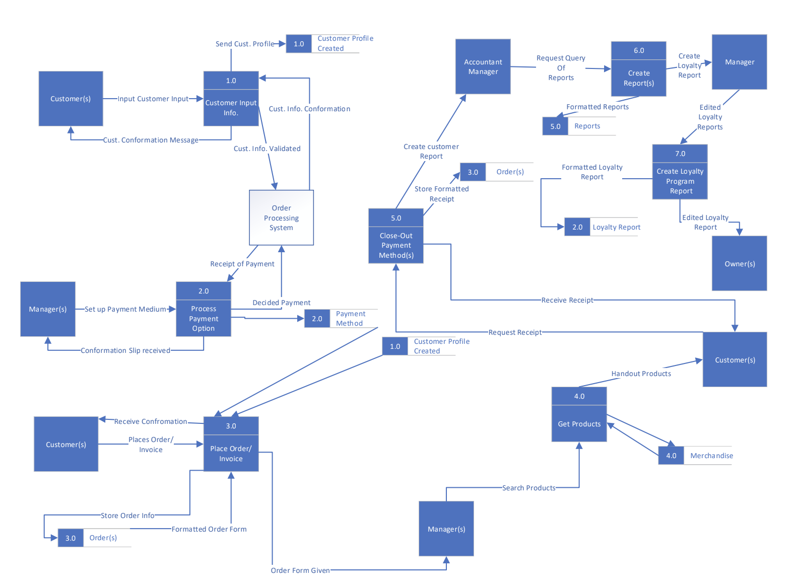

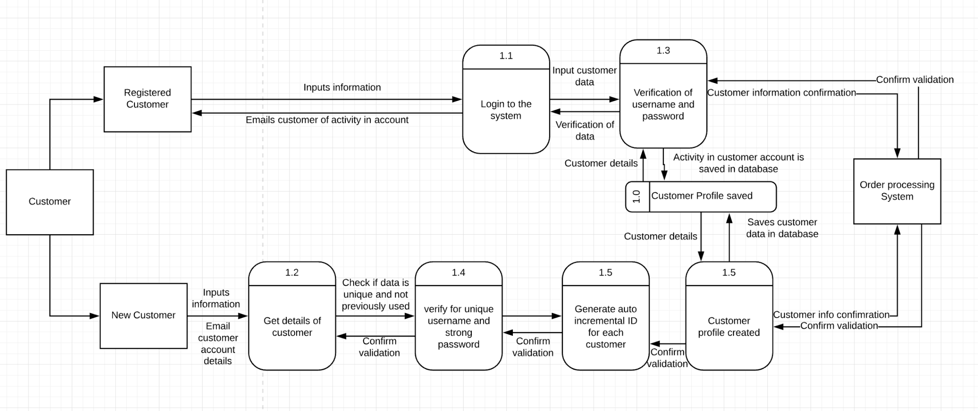

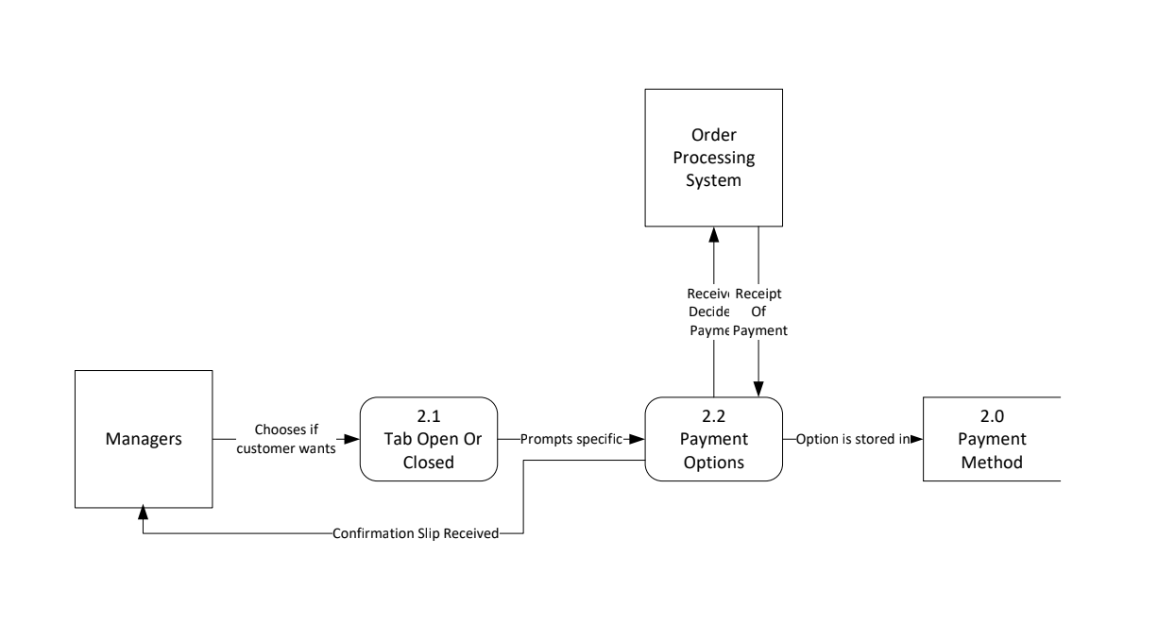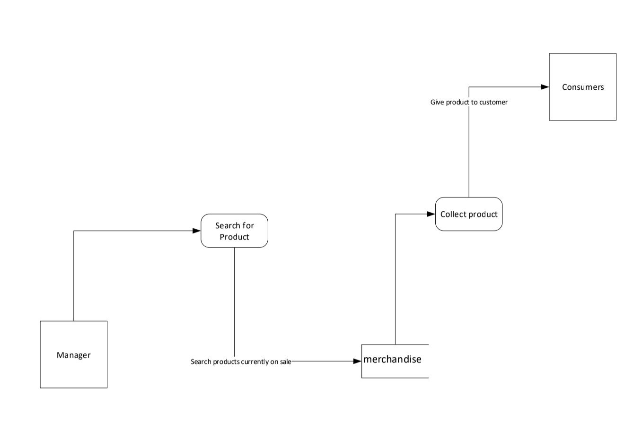

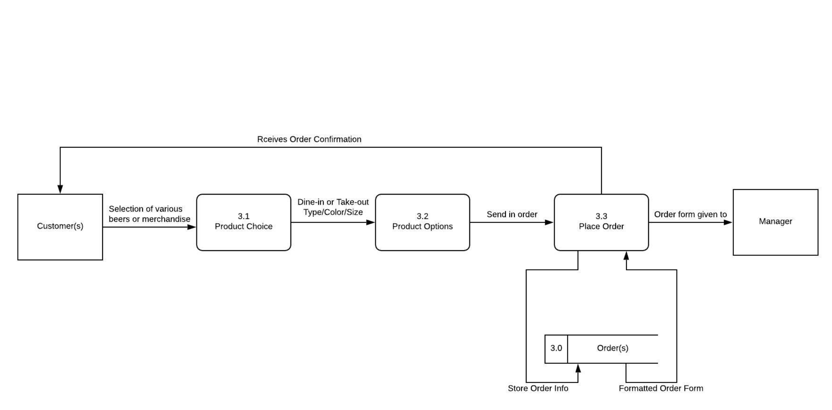

Missing 1 dfd

# Required system data dictionary

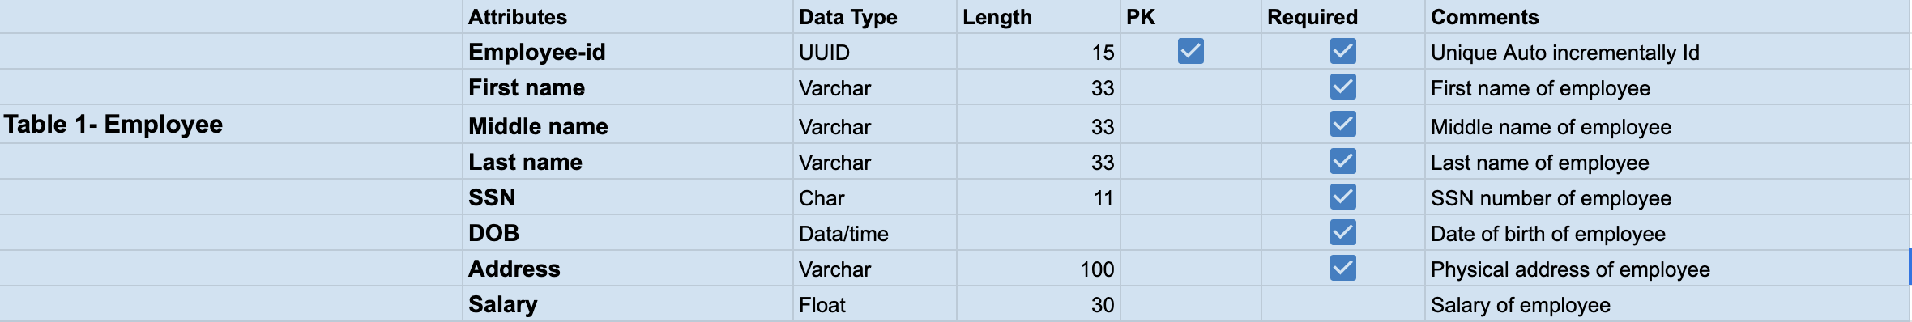



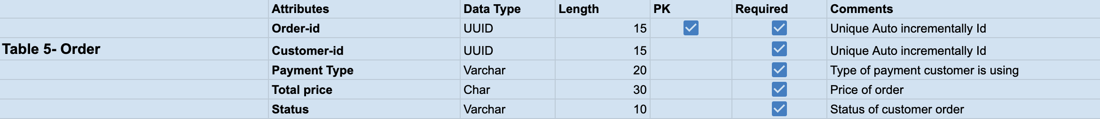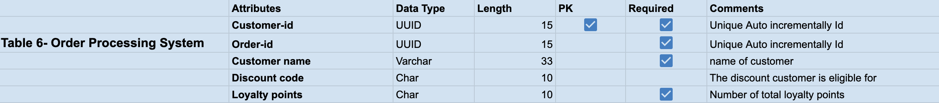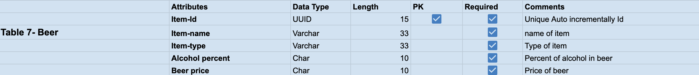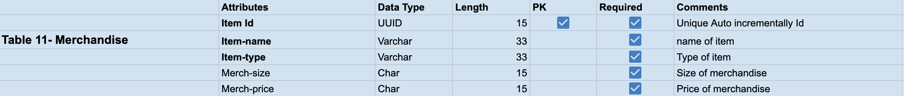

# Required System Feasibility Analysis

(Technical, Economic, Operational, and Scheduling feasibilities)

*Technical Feasibility*

The technical feasibility analysis was based on the company’s current resources (hardware and software) and technology that are required to accomplish the user requirements within the allocated budget and time. For this, we had to check whether the current technology could be upgraded with our proposed solution being added onto the current system, or if we would have to develop a new, independent system.

*Economic Feasibility*

The economic feasibility analysis was based on whether the required solution is capable of generating any financial gains for the organization. It included costs incurred on the software development team, estimated hardware and/or software costs, cost of performing a feasibility study, cost of training employees and so on.

*Operational Feasibility*

The operational feasibility analysis was based on assessing the extent to which the required solution performs a series of steps/tasks to solve business problems and user requirements. Our proposed solution will not require too much time to educate the employees, as it is essentially an upgrade that will not drastically change the current system and will be fully functional and ready to be used as soon as implemented. The recommended solution will be heavily used on a daily basis to help employees perform daily operations in a more efficient manner. Therefore, our proposed solution has a high probability of being implemented.

Scheduling Feasibility

The scheduling feasibility analysis was based on estimating the time required for completing the project. This is done by measuring the time required for the development of the system, which is based on the system requirements. Through this, efforts are made from our team to allocate manpower to their respective tasks which allows us to ensure completion of the project within the deadline.

# Application Architecture Diagram

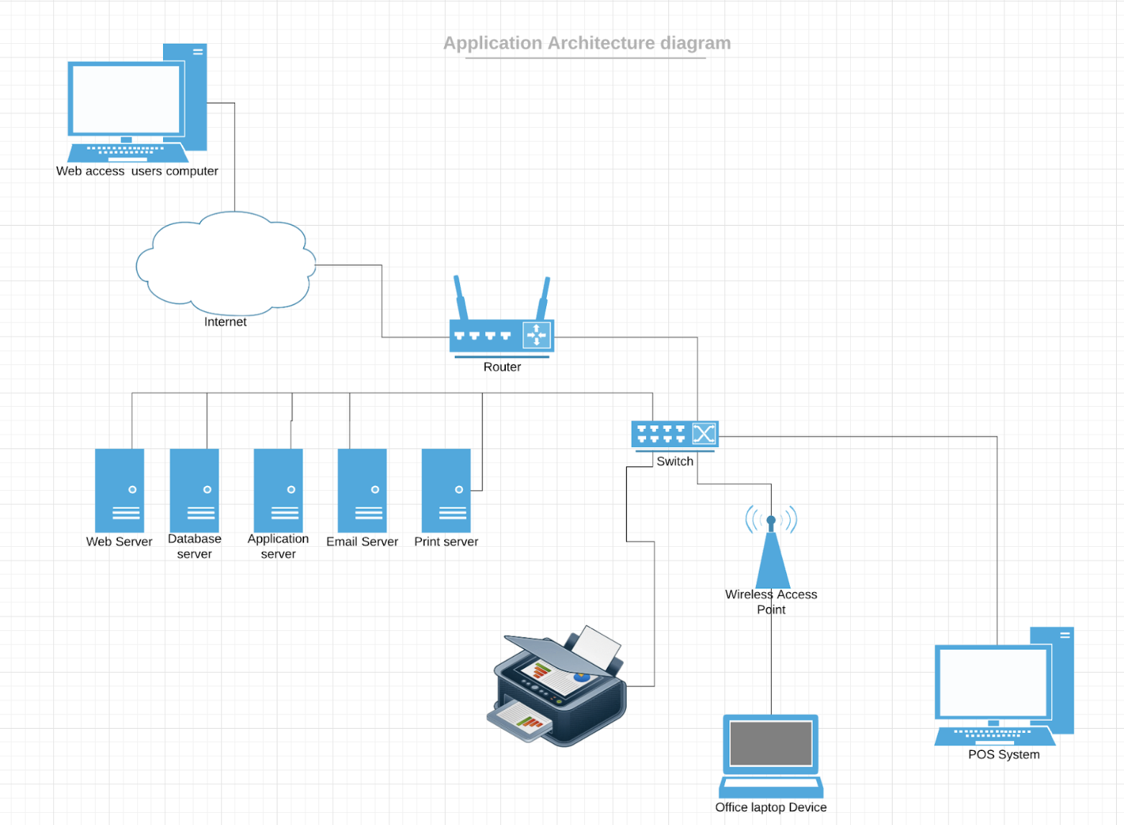

# Data Acquisition and Data Conversion Strategy

Klaus Brewing Company currently stores and files their customer and merchandise data in paper files in multiple folders and a point-of-sale system that is linked to transactions by said customers. The transactions are held in the front two computers in the taproom at the facility. Once paper files become old and outdated in regards to management they are filed in file cabinets in the facility. In order to fully convert to the new proposed system, the older files that are stored in the cabinets will need to be converted into digital format.

With the use of scanners and tri-copied receipt material, the documents will be filed in the system to be accessible on the computer. Depending on the type of file, the document will be saved as is in the system. The saved electronic files will be then converted into a text file, and formatted to the conditions we will have set for the client information in the database. Due to the amount of files needed to be converted and stored, the use of external hard drives or the cloud is needed. Finally, the use of an SQL database to store and format the data will be occurring.

# Initial Draft of Testing Plan for Application and Database Creation

One of our tests will be on whether the customer’s transactions with Klaus Brewing are being stored and tracked for the loyalty program, using Final Path Application. One way to test could be by making a dummy account and then having an employee put in certain orders to see if they will be saved on the database in relation to the dummy account email we provide. The dummy account will also have personal information details that have been filled out with the use of forms. We will check to see if the form filled by the dummy account is updated to our database correctly. The dummy account also needs to be able to see how many loyalty points it has accumulated. Information regarding this will be on the right side of the window. We will check to see if the loyalty progression being shown is correlating with the reports in our database.

If all this is successful, then we have been able to make our application track customer transactions with Klaus Brewing for the loyalty program.

Another test we would need to do is for when the customer forgets their login information or want to update their information. The dummy account could still be used to test this possibility by clicking the “forgot password” button and seeing if all the prompts we made work correctly. Some of those prompts are: asking for the email after saying they have forgotten their password, giving the option of sending the email to the phone number related to the dummy account if the customer has forgotten their email, then after that the customer types in the email and the email receives a link with a temporary password, the customer comes back to our page and types in the temporary password in a new window to log in successfully; after this, the customer has to make a new password by clicking the change password section in the profile. If all these works successfully for the dummy account, then the test was a success.

# Application Prototype

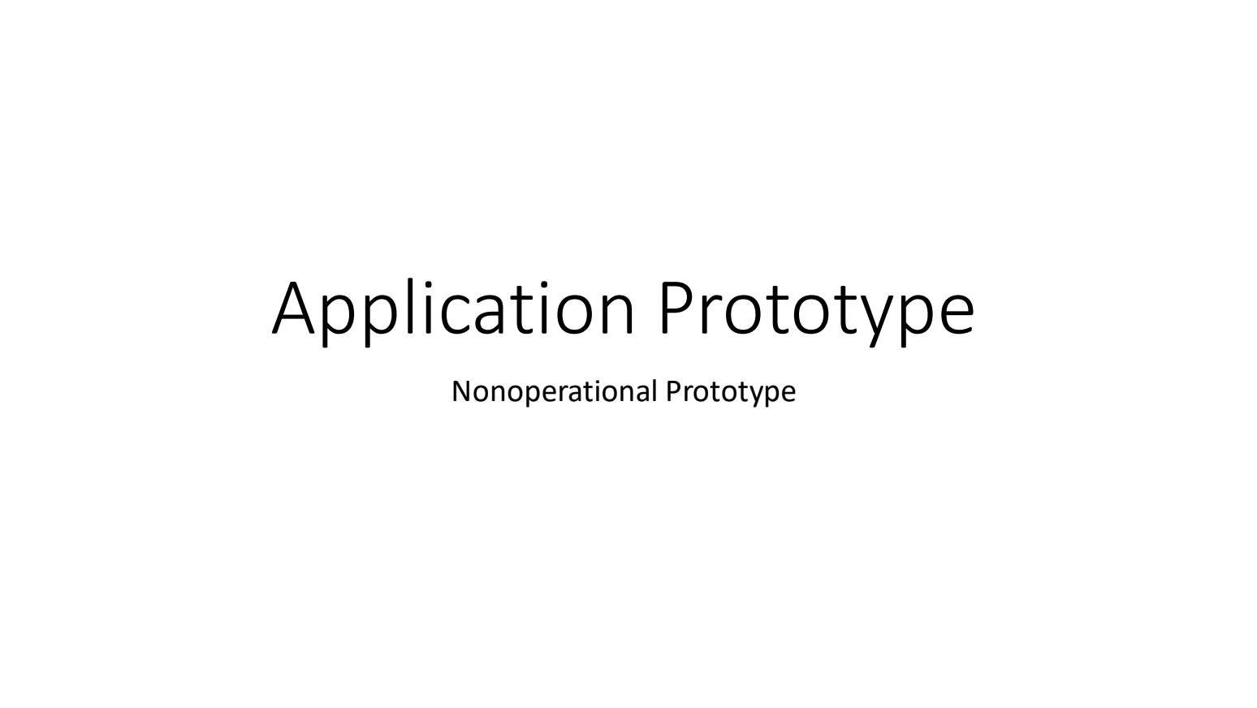

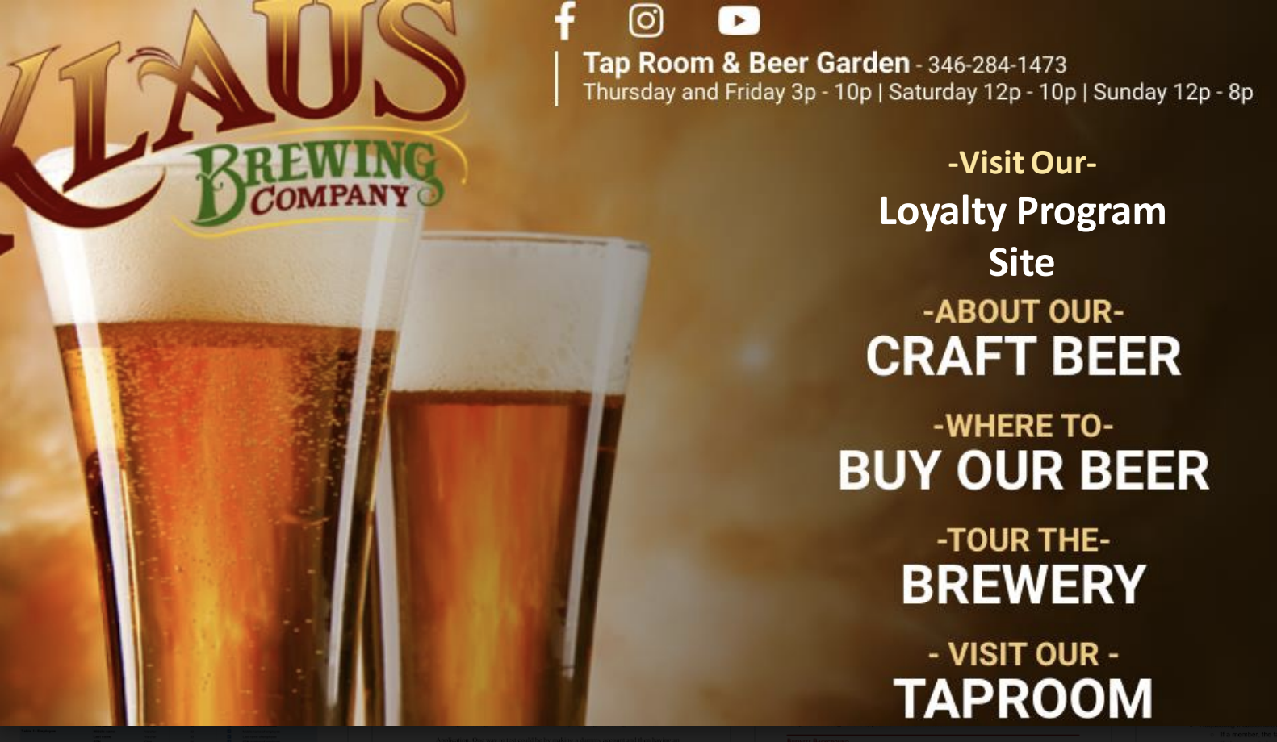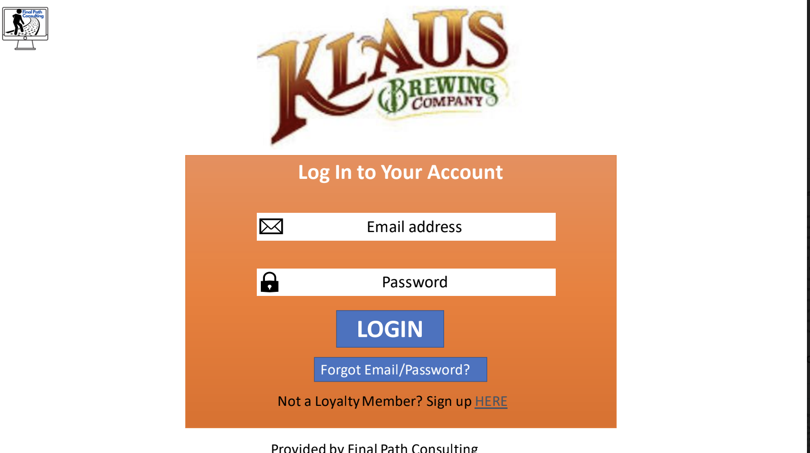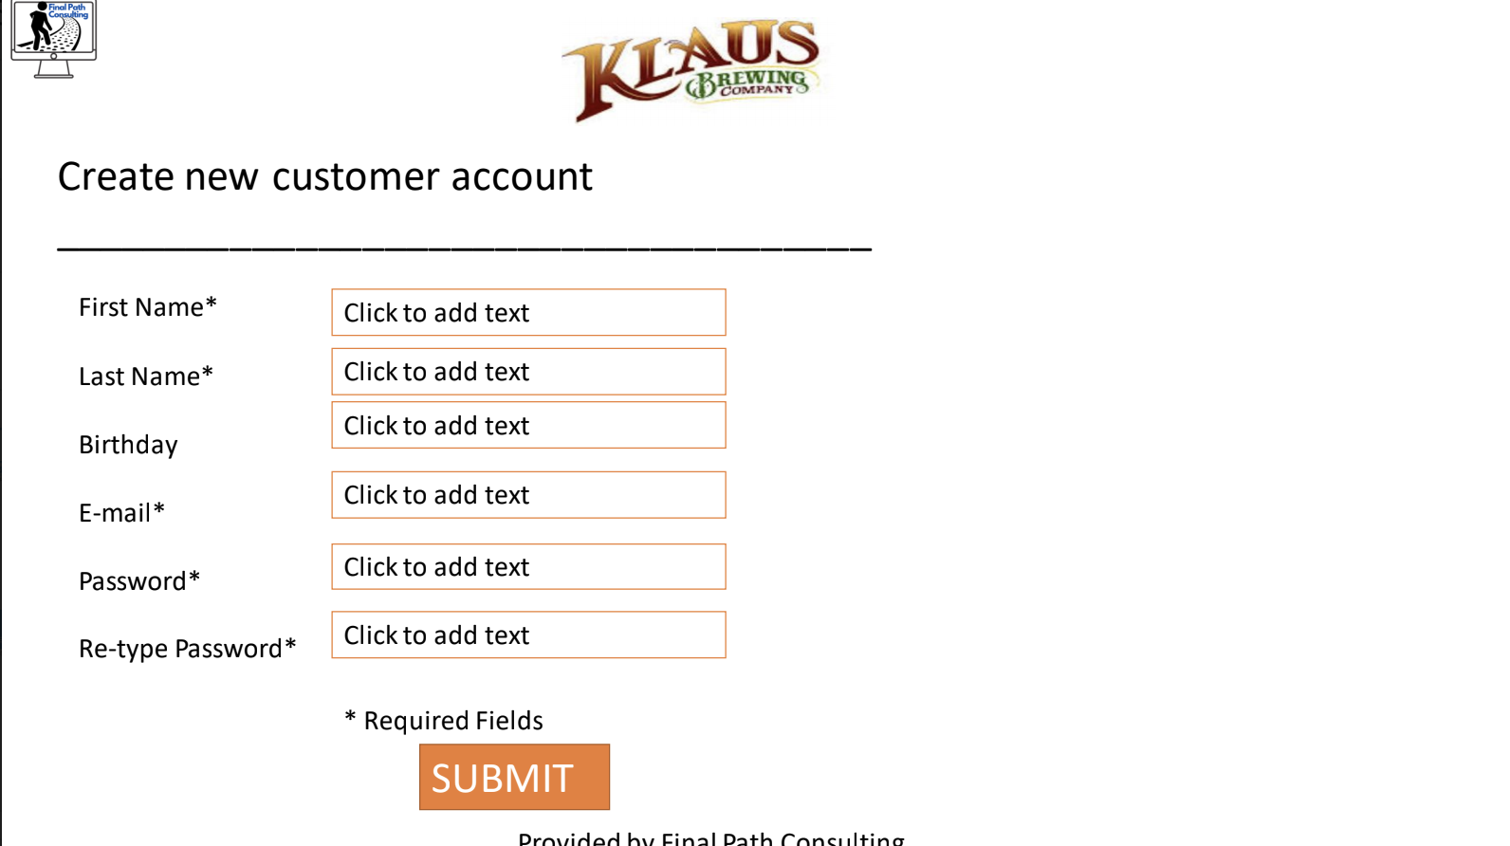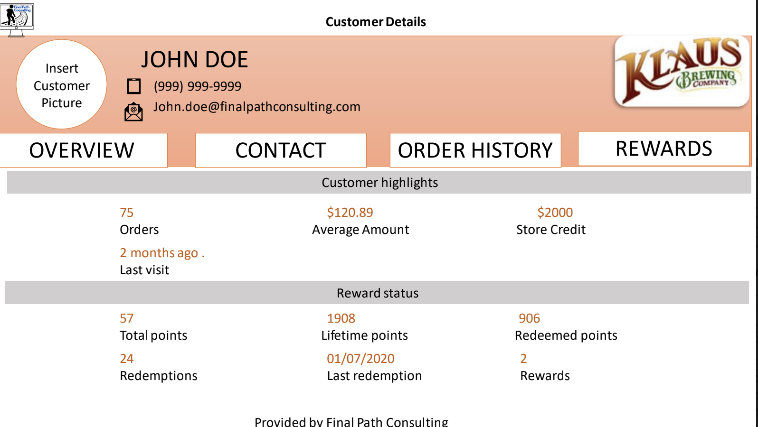

# Reports

Adekunle Kukoyi

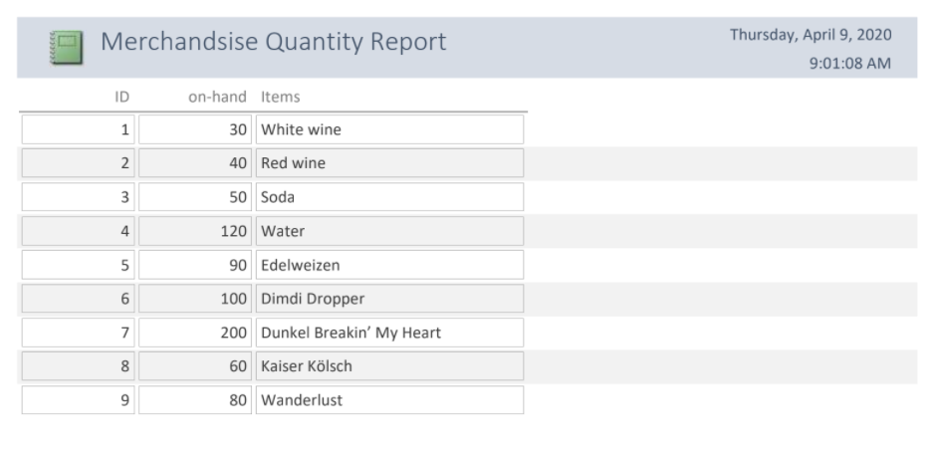

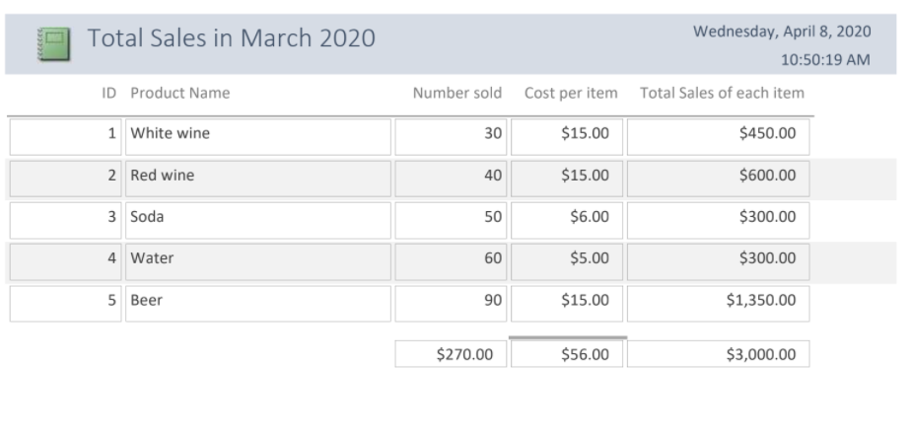

Chantera Lazard

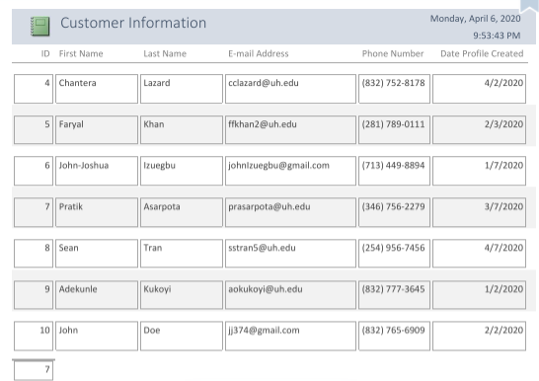

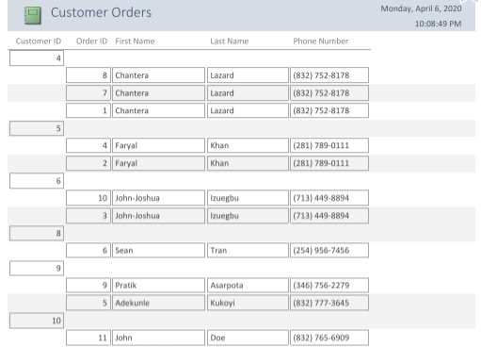

Pratik Asarpota

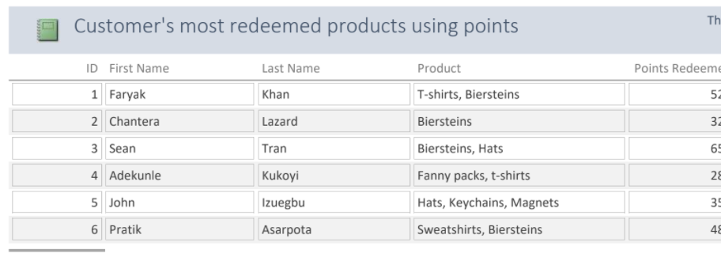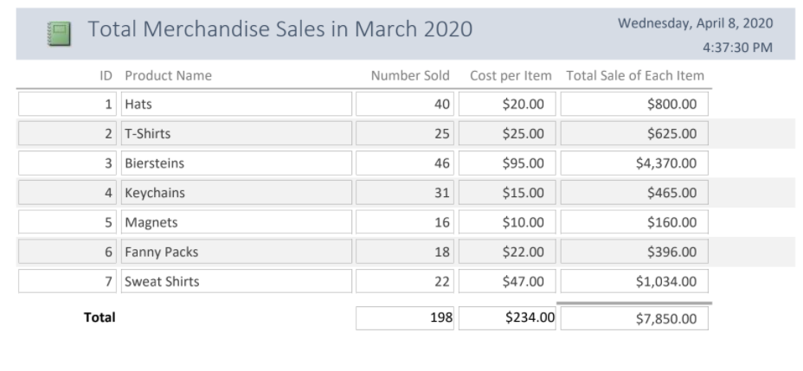

Sean Tran

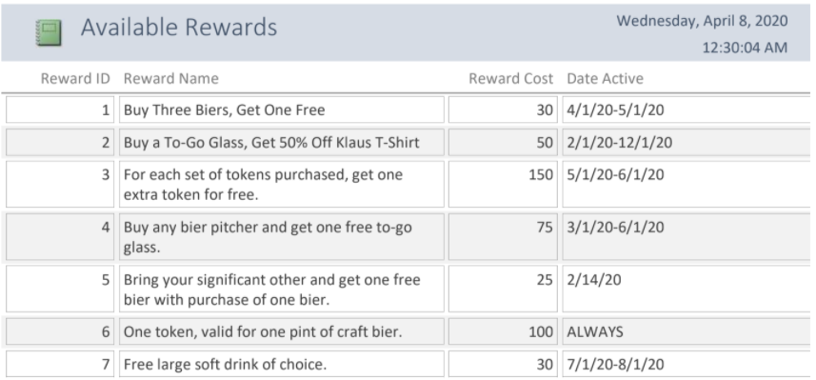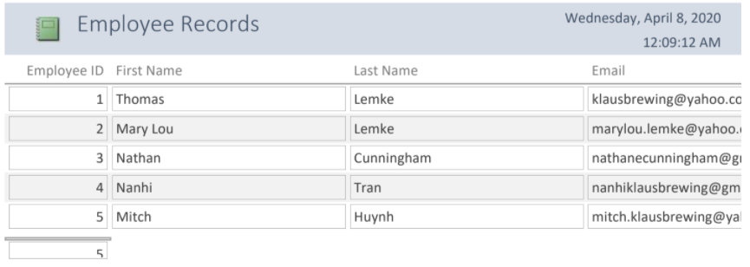

Faryal Khan

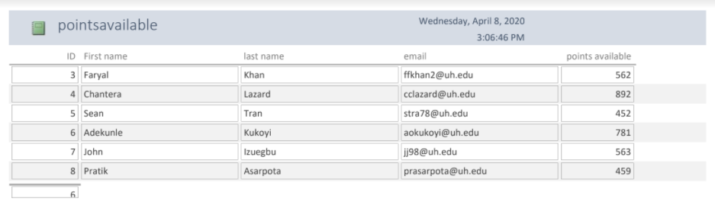

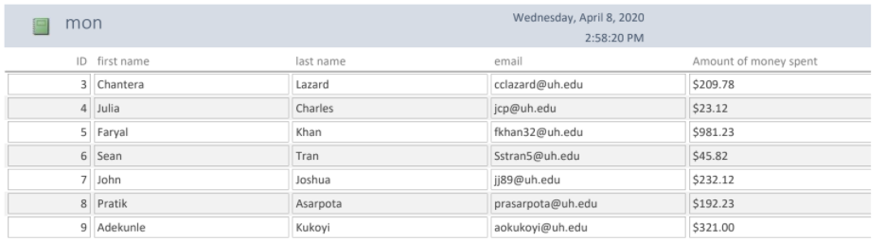

John-Joshua Izuegbu

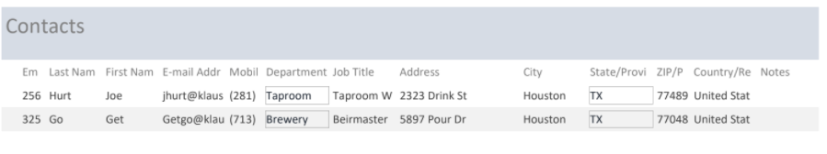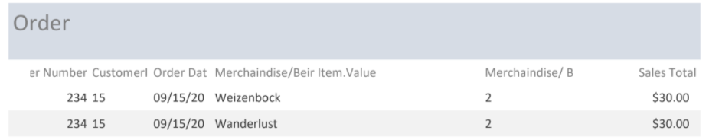

# Updated Listing of Authors per Deliverable

Listing of authors per deliverables

1. Table of Contents - John-Joshua Izuegbu
2. Team Members - John-Joshua Izuegbu
3. Client Memorandum of Agreement - Sean Tran
4. Team Communications Plan - Faryal Khan
5. Client Organization’s History/Background - John-Joshua Izuegbu and Sean Tran
6. Client Organization Timeline - Chantera Lazard and Pratik Asarpota
7. Client’s Organization Chart - Chantera Lazard and Sean Tran
8. Project Selection analysis - Chantera Lazard, John-Joshua, Faryal Khan(Contributor)
9. Initial Problem Statement - John Joshua
10. Problems and Requirements List - John-Joshua, Chantera Lazard, Sean Tran
11. Scope Diagram - Pratik Aasarpota, Chantera Lazard
12. Data Gathering Goals - Faryal Khan
13. Data Gathering Methods - Chantera Lazard
14. Data Gathering Questions - Faryal Khan
15. Team Matrix - John-Joshua
16. Data Gathering Results - Sean Tran
17. Current System Description - Chantera Lazard
18. Current System Problem Description - Faryal Khan
19. Client Organization Objective List - John-Joshua Izuegbu
20. Client Applications(System)Objective List- Adekunle Kukoyi
21. Individual Users Objective List - Sean Tran
22. STROBE Analysis - Chantera Lazard, Adekunle Kukoyi and Faryal Khan
23. Samples of Records - Sean Tran
24. Initial Project Work Breakdown Structure - Sean Tran
25. Gantt Chart - Sean Tran
26. PERT Diagram - Sean Tran
27. Users/Stakeholders Analysis - Chantera Lazard
28. Initial Feasibility Analysis - John Joshua Izuegbu,Adekunle Kukoyi
29. Critical Requirements Analysis Objective Tree -
30. Current Business Rule List - Sean Tran and Chantera Lazard
31. Current Business Activity List - Chantera Lazard,Pratik Asarpota
32. Current Event Response Table - Adekunle Kukoyi and Chantera Lazard
33. Current System Data Flow Diagram - John-Joshua Izuegbu
34. Current Data Dictionary - John Joshua Izuegbu
35. Current Entity Relationship Diagram - Sean Tran
36. Client’s SWOT Analysis - Faryal Khan
37. System’s Proposal - Faryal Khan, Chantera Lazard, Sean Tran, John-Joshua, Adekunle Kukoyi
38. Required System Business Rule List - Faryal Khan and Pratik Asarpota
39. Required System Business Activity List - Chantera Lazard and Adekunle Kukoyi
40. Use Case Scenarios - All team members
41. Required System Business Activity List - Pratik Asarpota and Faryal Khan
42. Required System Event Response - Adekunle Kukoyi and Chantera Lazard
43. Required System Feasibility Analysis - Pratik Asarpota and Faryal Khan
44. Required System Entity Relationship Diagram - Sean Tran and John-Joshua Izeugbu
45. Data Acquisition and Data Conversion Strategy - Sean Tran and John-Joshua Izeugbu
46. Initial Draft of Testing Plan for Application and Database Creation - Adekunle Kukoyi and Chantera Lazard
47. Application Architecture Diagram - Chantera Lazard and Faryal Khan
48. Application Prototype (All reports and menus) - Chantera Lazard and Faryal Khan
49. Unique Reports - All team members
50. Required System DFD - John-Joshua Izeugbu and Sean Tran
51. Required System Entity Relationship Diagram - Sean Tran and John-Joshua Izeugbu
52. Lower Level DFD Diagram - All team members
53. Requires System Data Dictionary - Faryal Khan and Pratik Asarpota
54. Executive Summary of Project - John-Joshua Izeugbu
55. References - Faryal Khan , Chantera Lazard
56. Listing Of Authors - Faryal Khan, Adekunle Kukoyi and Chantera Lazard
57. Binder - Chantera Lazard, John-Joshua
58. Powerpoint Presentation - Faryal Khan

# Complete List of References

[INSERT COMPLETE LIST OF REFERENCES HERE]

# Executive Summary of Project

[INSERT EXECUTIVE SUMMARY OF PROJECT HERE]

# Updated Client Background and Information

Klaus Brewing Company was founded by a local group of family and friends led by passionate brewer Thomas Lemke. Focused on bringing the under-served German-style beers to a wide range of consumers, from beer aficionados to new converts alike. They chose the name Klaus because they wanted a strong traditional German name. The name's meaning is "The People’s Victory". The company feels being able to offer people the ability to experience great locally crafted beer in a welcoming environment is truly a victory for everyone.

Recently, during the first quarter of 2020, a global pandemic took place due to which countries, cities, states nation-wide were all on a lockdown. This event had negatively affected a lot of people’s jobs and livelihoods. Some were fortunate, others not so much. Unfortunately, Klaus Brewing Company was negatively affected by this disaster and was forced to fire the entire lower level employees – Biertenders, Brewers, and the Sales Rep. They were only able to keep the managers employed.

# Final Problems and Requirements List

[INSERT FINAL PROBLEMS AND REQUIREMENTS LIST HERE]